INTERNATIONAL TRADE
International Trade is the buying and selling of goods and services across the national boarders. It deals with the economic inter- dependence among Nations. It analyses the flow of goods, services and payments between a nation and the rest of the world. This economic inter- dependence among Nations is affected by and in turn influences the political, social, cultural and military relations among Nations. If you enter a supermarket and can buy banana from SA, coffee from Brazil or a bottle of wine form USA, you are experiencing international trade. International trade is the exchange of goods and services between countries. This type of trade gives rise to a world economy in which prices or demand and supply affect and are affected by global events. Trading globally gives consumers and countries the opportunity to be exposed to goods and services not available in their own countries. A product that is sold to the global market is an export and a product that is bought from the global market is an import. The countries trade internationally when there are not enough resources or capacity to satisfy domestic needs. By developing and exploiting their domestic resources, countries can produce a surplus. Therefore, international trade exists because of;
- Differences in prices. A foreign country can produce more cheaply
- Quality. A foreign country may be productively superior
- Availability. It may not be possible to produce the item locally due to lack of resources.
- Demand. This might be greater than supply of a commodity domestically.

Advantages of international trade.
- Gains from trade due to lack of self sufficiency
- It provides variety of goods in the market
- It increases the market size for the products
- It encourages a country to specialize in producing those goods in which they are efficient
- Increased volume which increases economies of scale and reducing the average production costs
- Trade increases competition thereby lowering world prices which increases the consume satisfaction and purchasing power
- It breaks down the inefficient domestic monopolies
- Increases the quality of goods and services
- It encourages technological transfers and innovation activities
- Creates employment opportunities
- Increases economic growth
- Leads to product diversification
Disadvantages
- Over specialization resulting in structural unemployment
- Certain industries are over competed increasing the problem of unemployment and scarcity of some products.
- Leads to dumping
- May lead to environmental pollution and deterioration
- Overexploitation of resources
- Creation of monopolies in terms of multinational corporations
- May lead to smuggling
- May lead to dependency of some countries to others leading to net-importation
- May lead to criminal activities and political unrest.

TRADE BASED ON ABSOLUTE ADVANTAGE
According to Adam Smith, for 2 Nations to trade with each other voluntarily, both Nations must gain. If one Nation gained nothing (lost) it would simply refuse to trade. He therefore contended that trade between 2 Nations is based on absolute advantages.

Then if two Nations have absolute advantage in the production of one commodity each, both nations can gain by such specializing in the production of the commodity of its absolute advantage and exchange part of its output with the other nation for the commodity of its absolute disadvantage.

This process utilizes resources in the most efficient way and the output of both commodities will rise. This increase in output of both commodities measures the gain from specialization if production available is to be divided between the two nations through trade. E.g., suppose Uganda is efficient in growing bananas but inefficient in growing maize and Kenya is efficient in growing maize but inefficient in growing the production of bananas. Then Uganda has absolute advantage over Kenya in the production of bananas but an absolute disadvantage in the production of maize and vice versa.

Under such circumstances both nations would benefit if each specialized in the production of a commodity of its absolute advantage and then trade with the other nation.

In this case, Uganda would specialize in the production of bananas and produce more than what is needed domestically such that it could exchange the surplus for maize produced by Kenya. As a result, more wheat and more bananas will be grown and consumed and both countries will gain.

Illustration of the law of Absolute Advantage
Assuming one hour of labor time produces 6 tones of bananas in Uganda and only 1 tone in Kenya. On the other hand, 1 hr. of labor produces 5 tones of maize in Kenya but only 4 tones in Uganda. This means that Uganda is more efficient or has absolute advantage over Kenya in the production of bananas while Kenya is more efficient or has absolute advantage over Uganda in the production of maize.

With trade, Uganda would specialize in the production of bananas and exchange the surplus with Kenya and likewise Kenya would specialize in the production of maize and exchange the surplus with Uganda.

The law of absolute advantage states that a country will produce and export that commodity in which it is more efficient compare to the other.

Illustration
Table 1 | Uganda | Kenya
Bananas | 6 | 1
Maize | 4 | 5

From the table above, if Uganda exchanges 6 tones of bananas for 6 tons of maize with Kenya, Uganda gains 2 tones of maize or saves ½ hours of labor since Uganda can only produce 6 tones of bananas and 4 tones of maize domestically. Similarly, the 6 tones of bananas that Kenya receives from Uganda would require Kenya 6 hours to produce. Kenya would instead use these 6 hours to produce 30 tones of maize (6hrs x 5tones). By being able to exchange 6 tones of maize for 6 tones of bananas from Uganda, Kenya gains 24 tones of maize.

The fact that Kenya gains much more than Uganda is not important at this time, what is important is that both nations benefit from specialization in production and trade.

Absolute advantage however explains a very small part of world trade today such as trade between developed and developing countries. It does not explain most of the trade especially among developed countries.
Because of such inadequacies in the theory, David Ricardo came up with the law of comparative advantage, which truly explains the basis for and gains from trade.
In this perspective, absolute advantage can be seen as only a special case of the more general theory of comparative advantage.

TRADE BASED ON COMPARATIVE ADVANTAGE
David Ricardo came up with the law of comparative advantage that truly explains the basis for and gains from trade.
The law of comparative advantage is one of the most important and still un-challenged laws of economics with many practical applications.
According to this law even if one nation is less efficient than the other is (has absolute disadvantage) in the production of both commodities, there is still a basis for mutually beneficial trade.
The first nation should specialize in the production and export the commodity in which its opportunity cost is less compared to another i.e., a commodity of which its comparative advantage is greater.
Table II | Uganda | Kenya
Bananas | 6 | 1
Maize | 4 | 2

According to the above information, Uganda has a comparative advantage in production of bananas in which it incurs less opportunity cost while Kenya has it in maize production. Therefore, Uganda will specialize in production of bananas and export part of it to Kenya while Kenya will specialize in production of maize in which it has a comparative advantage and export part of it to Uganda.
Note: In a two-nation two-commodity world, once it is determined that one nation has a comparative advantage in one commodity, and then the other nation must necessarily have a comparative advantage in the other commodity.

To prove the law of comparative advantage, you must show that both Uganda and Kenya can both gain by each specializing in the production and exportation of the commodity of its comparative advantage. E.g., suppose Uganda receives 4 tones of maize from Kenya in exchange for 6 tones of bananas Uganda would be indifferent to trade since it can produce 4 tones of maize domestically by utilizing resources realized in giving up 6 tones of bananas and definitely Uganda will not trade if it receives less than 4 tones of maize for 6 tones of bananas.

Similarly, Kenya will be indifferent to trade if it had to give up 2 tones of maize for each tone of bananas it would receive from Uganda and certainly it would refuse to trade.

To show that both nations can gain, we suppose that Uganda can exchange 6 tones of bananas for 6 tones of maize from Kenya, thus Uganda gaining 2 tones of maize. Kenya would also gain if we consider the fact that the 6 tones of bananas it receives from Uganda would require it 6 hours of labor to produce. Kenya could instead use these 6 hours to produce 12 tones of maize and give up only 6 tones of maize for 6 tones of matooke it receives from Uganda. Thus, Kenya would gain 6 tones of maize.

Once again, the fact that Kenya gains much more from trade than Uganda is not important at this point, what is important is that both nations can gain from trade even if one of them in this case Kenya is less efficient than the other in the production of both commodities.

TERMS OF TRADE (TOT)
The terms of trade refer to the rate at which the goods of one country exchange for the goods of another country. It is a measure of the purchasing power of exports of a given country in terms of its imports. It represents the ratio between a country`s export price to its import price at a given time.ie how many units of exports are required to purchase a single unit of import. TOT = P_{x}/P_{m} x 100. The ratio is calculated by dividing the price of the exports by the price of the imports and multiplying the result by 100. When more capital is leaving the country than is entering the country then, the TOT will be less than 100%. When the TOT is greater than 100%, the country is accumulating more capital from exports than it is spending on imports. It is used as an indicator of a country`s health. Changes in export and import prices influence the TOT of a country. An improvement or increase in TOT indicates that export prices have gone up while that of import has either remained the same or has dropped. This means that for every unit of export sold can buy more units of imported goods. Thus, the country is said to have gained from trade. If the import prices rise faster then export prices, then the TOT are said to have deteriorated. A given volume of exports has to be sold to finance a given amount of imported goods and services. This leads to a fall in the standard of living because imports of necessities are more costly. The TOT fluctuate in line with changes in export and impot price. This means that the exchange rate and the rate of inflation can influence the direction of any change in the TOT. However, it is important to understand what caused the price to increase or decrease.

Factors that influence the TOT
- Reciprocal demand and supply
- Changes in demand
- Changes in factor endowments
- Changes in technology
- Changes in tastes and preferences
- Economic growth
- Tariff
- Exchange rate
- Market condition
- Import substitution policy
- International capital flows
- Changes in general price level
- Political climate
- Devaluation

PROTECTIONSIM
The term protection refers to a policy whereby domestic industries are protected from foreign competition. The aim is to impose restrictions on the imports of low-priced products in order to encourage domestic industries. This may be through tariff or non-tariff barriers (NTBs).
Tariff
A tariff is a tax or duty levied on goods when they enter or leave the national boundaries
Objectives
- Protect domestic industries
- To guard against dumping
- To promote indigenous research and development through innovations
- To conserve the foreign exchange reserves in the country
- To correct balance of payment (BOP) problems
- To protect importation of harmful importation
- To collect government revenues
- To collect data for national planning
- To control smuggling
Non-Tariff Barriers (NTBS)
This is the way to restrict trade using trade barriers other than tariffs. These are used to control the amount of trade countries conduct with other countries. The countries use these barriers based on the availability of goods and political alliances with trading countries. Such barriers release countries from paying extra tax on imported goods and create other barriers that have a meaningful monetary impact. In most cases, countries use both the NTBs and tariffs.
Categories
- Specific limitations
- Quotas
- Embargoes or total bans
- Import licenses
- Local content requirements
- Exchange rate controls
- Minimum price on imports
- Customs and administration
- Valuation systems
- Ant-dumping practices
- Tariff classifications
- Documentation requirements
- Rule of origin (ROO)
- Fees other than tariffs
- Standards
- Standard disparities
- Pre-shipment inspections
- Packaging
- Labelling requirements
- Technical specifications
- Government participation in trade
- Government procurement
- Export subsidies
- Counterveiling duties
- Retaliations
- Voluntary export restraint (VERs)
- Domestic assistance programmes
- Charges on imports
- Import deposits
- Administrative fees
- Special supplementary duties
- Import credit discrimination
- Border taxes
- Customs bonds
- Others
- Infrastructures
- Weather changes
- Roadblocks
- Weighbridges
- Cargo checking
- Axle weight limitations
- Language differences
- Currency differences

EXCHANGE RATES
One currency is exchanged for another currency at this rate. It is the purchasing power of one currency against another. The currencies are traded in the foreign exchange market. The foreign exchange market operates daily 24/7 and there is no physical location for currency trading. Trading in exchange market is mainly to facilitate international tared and international investment. Exchange rates affect the price of exports, which form a significant part of AD and the price of imports hence the BOP. Therefore, exchange rates changes create a risk to those firms and individuals that hold assets in given currencies.
Transactions in foreign exchange are for;
- To buy foreign goods and services
- To make unilateral payments and transfers
- To hold deposits in foreign banks
- To make short term and long-term lending
Stakeholders in foreign exchange market
- Central bank intervenes to control and maintain the exchange rate
- Brokers. These speculators act as agents to facilitate trading between dealers. They actively and constantly monitor exchange rate offered by the international banks through computerized systems and are quickly to find an opposite party for the client. They disseminate quick information about currency quoted to many dealers. They help their clients obtain the lowest buying or the highest selling rates.
- Commercial banks who are the biggest participants
- The end users i.e., the importers, exporters, tourists, visitors etc.

Demand for forex
The demand for forex is a derived demand due to the demand for the foreign commodities and services.
Demand curve

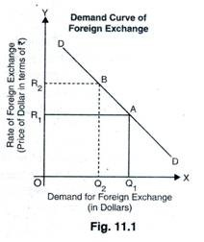
The demand curve is a normal downward sloping curve. A movement up the vertical axis represents an increase in the price of the shilling, which is equivalent to a fall in the price of the dollar. Therefore, an increase in exchange rate results in a decline in the value of the dollar

Supply of FOREX
The supply of a currency is determined by the domestic demand for imports from abroad. The more the country imports the greater the supply of foreign currency on the foreign exchange market
Supply curve
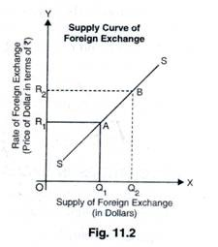
The supply curve slopes upwards because the domestic firms and consumers are willing to buy a greater quantity of foreign goods as the dollar becomes cheaper. Hence, the increase in the foreign goods demand is simultaneously an increase in the quantity of the dollar supplied because one has to convert the shilling into the dollar.

Equilibrium in foreign exchange market
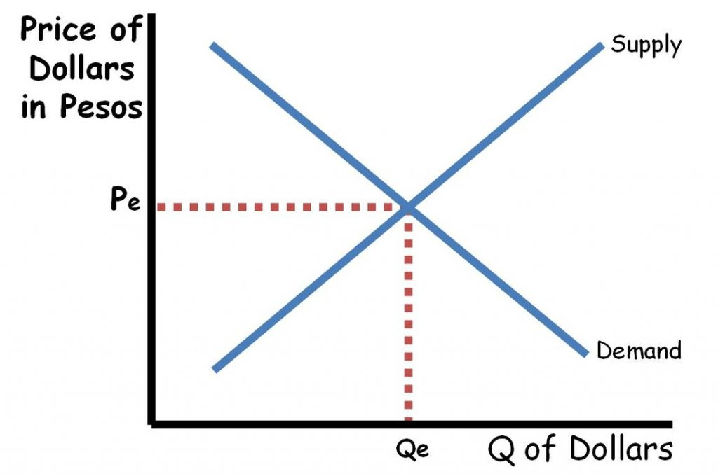

As in any market, the foreign exchange market will be in equilibrium when the quantity supplied of a currency is equal to the quantity demanded of a currency. If the market has a surplus or a shortage, the exchange rate will adjust until an equilibrium is achieved.

FOREIGN EXCHANGE REGIMES
Technical terms
Devaluation. This is the deliberate downward adjustment of a country's currency value. The government issuing the currency decides to devalue a currency. Devaluing a currency reduces the cost of a country's exports and can help shrink trade deficits.
Revaluation. A revaluation is a calculated upward adjustment to a country's official exchange rate relative to a chosen baseline, such as wage rates, the price of gold, or a foreign currency. In a fixed exchange rate regime, only a country's government, such as its central bank, can change the official value of the currency.
Depreciation. Currency depreciation is a fall in the value of a currency in terms of its exchange rate versus other currencies. Orderly currency depreciation can increase a country’s export activity as its products and services become cheaper to buy.
Appreciation. Currency appreciation refers to the increase in value of one currency relative to another in the forex markets. The value of a currency constantly changes based on supply and demand in the forex market. The fluctuation in values allows traders and firms to increase or decrease their holdings and profit off them.
- Fixed exchange rate
This is also referred to as pegged exchange rate where all exchange transactions take place at the exchange rate determined by the monetary authority in the country. The authority may fix the exchange rate by legislation or by intervention in the market. It may buy or sell currencies according to the needs of the country or may make policy decisions to appreciate or devalue the national currency

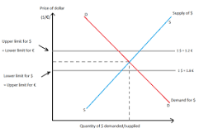

The purpose of a fixed exchange rate system is to keep a currency's value within a narrow band. Fixed exchange rates provide greater certainty for exporters and importers and help the government maintain low inflation.

- Flexible exchange rate
Also referred to as floating or fluctuating exchange rate is determined by the forces of demand and supply in foreign exchange market. The monetary authority does not intervene in the market. If there is excess supply of the currency, the value of that currency in the market will fall. This leads to depreciation of the exchange rate. On the other hand, a shortage of a currency will lead to appreciation of the exchange rate leading to equilibrium in the foreign exchange market.

Factors that influence or determine the exchange rate
- Changes in prices
- Changes in interest rate
- Changes in import and export
- Capital movements
- Influence of banks through LC etc.
- Changes in bank rate
- Influence of speculators
- Structural influences
- Political climate
- The level of economic growth

Balance of Payments (BOP)
A country’s balance of payments is a systematic record of every single economic transaction between the consumers of the home country and consumers in the rest of the world over a specific period, usually a year, quarter or month. By every transaction we mean invisible and visible trade (exports and imports of goods and services), unrequited transfers, and capital movements. Unrequited transfers are one-way payments of money, expecting nothing in return, usually done by governments as foreign aid, debt forgiveness, and membership dues to a global organization. This is the method countries use to monitor all international monetary transactions at a specific period of time usually one year. All trades conducted by both the private and public sectors are accounted for in the BOP in order to determine how much money is going outside the country and coming in. The balance of payments of a country is therefore a complete picture of its international transactions. If the country receives money, it is credited and when it pays out it is entered as debt. Theoretically BOP = 0 meaning it must balance where receipts from exports exactly clears the payments for imports

Balance of Trade (BOT)
This is the most important in the overall BOP and it measures the relationship between the total value of exports and imports. It is the difference between the monetary value of exports and import of output in an economy over a period of time. The balance of trade is a statistical tool that helps economists understand how strong a country’s economy is in relation to other nations. A positive BOT is a trade surplus a negative BOT is a trade deficit.

Visible and invisible BOT
Visible trade, in economics, is the importing and exporting of physical goods, products that you can touch. The product being traded could be a raw material such as coal, oil or wood, or the finished product, such as a car or smartphone. Visible trade refers to the exchange of physical goods in every stage of production. They are also known as international merchandise transactions. Invisible includes receipts from services such as tourism, transport, banking, insurance etc. Invisible trade, or the exchange of non-tangible goods, represents an increasing percentage of the world's business. Any transaction that is associated with a value but not with physical goods could be called an invisible trade. The concept of invisible trade is used to define business activities that involve monetary exchange but not an exchange of physical goods. The purchase of an insurance policy by a firm in one country from a company in another country is such a transaction. The BOP account of a country is constructed on the principle of double entry book keeping. It is divided into three parts; current account, capital account and financial account.

A nation’s current account balance is the total exports of visible and invisible products, minus all visible plus invisible imports. If an economy exports, more than it imports it has a trade surplus. A trade deficit occurs when imports are greater than exports. The current account includes a nation's net trade in goods and services, its net earnings on cross-border investments, and its net transfer payments. The capital account consists of a nation's transactions in financial instruments and central bank reserves. The capital account consists of a nation's transactions in financial instruments and central bank reserves. It records international transactions, which affect assets and liabilities of domestic country with rest of the world. Items (4) and (8) of the table indicate changes in stock magnitudes and refer to capital receipts and payments .Government of a country may borrow (get loan) from another government; a firm may issue stocks abroad or a bank may float a loan in a foreign country. The sum of all transactions recorded in the balance of payments should be zero; however, exchange rate fluctuations and differences in accounting practices may hinder this in practice.

A hypothetical simplified example of a country’s Balance of Payment Account is given in the following table. It has two sides—credits (receipts) on the left side and debits (payments made) on the right side.

Balance of Payment Account
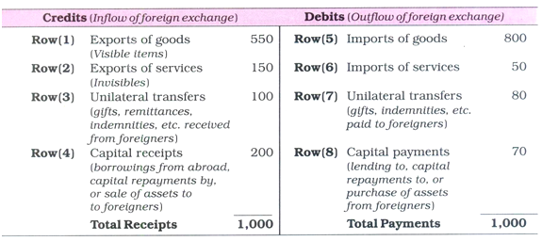

BOP account records a country is all economic transactions with ROW which Involve inflow or outflow of foreign exchange.

Factors that affect the BOP
- The cost production
- The cost and availability of raw materials
- Exchange rate movements
- Restrictions or protectionism
- Inflation
- Level of economic growth
- Nature of goods exported and imported
- Technological changes
- Foreign currency reserves: To compete effectively in international markets, a nation must have access to imported machinery that enhances productivity, which may be difficult if forex reserves are inadequate.
- Political climate in the country
- Foreign direct investment (FDI)

