**BRE2207-LECTURE NOTES**

**COST BUDGETING**

Cost budgeting is a process of creating a financial plan and budget using cost estimations. Cost budgeting includes the estimation of costs, setting a fixed budget, and managing and controlling the actual costs (compared to the estimated ones). A ***cost budget*** is a tool that estimates the project costs. The costs must be allocated to the activities or work packages for a project.

**Benefits of cost budgeting**

* Improves efficiency-Financial professionals can use cost budgeting to analyze their project expenses. This helps reduce waste and improve efficiency.
* Improve profitability-A cost budget helps improve overall costs, which in turn improves profitability.
* Meeting business goals-Helps professionals meet their business goals by creating a strategy for each project.

***Individual assignment-Add three more benefits.***

**Steps to follow to develop a cost budget**

1. Set budget guidelines-This entails setting goals and objectives and time frame for your budget parameters. For example, creating a semi-annual budget for your first 6 months.
2. List all costs-This entails listing all the expected costs for the budget. For instance, including all your direct and indirect costs, fixed and variable costs.

***Individual assignment: Is there a difference between direct and fixed costs; indirect and variable costs?***

1. Estimate expected costs-Here, you may contact an industry professional to guide you.
2. Set the timeline-This helps plan your costs throughout the period to ensure you have enough funds. For instance, for quarterly budget, you may set weekly or monthly deadlines.
3. Analyze and polish-Analyze the cost budget at the beginning of a project to improve your cost efficiency. This also entails tracking your actual costs and comparing these to the estimates.

***Difference between estimated costs and budgeted costs.***

Although these related ***(estimated costs and budgeted costs)*** are often used in project management and financial planning, they refer to distinct concepts:

An ***estimated cost*** is an approximate expense that will be incurred to complete a project or produce a product. It is typically based on historical data, expert judgment, and assumptions about future costs. A ***budgeted cost***, on the other hand, is a specific allocation of funds for a project or a period, based on the estimated costs. It represents the maximum amount that can be spent on the project.

**WORK BREAKDOWN STRUCTURE**

A *Work Breakdown Structure* (WBS) in construction is a hierarchical way of organizing a building project. WBS is a single document that divides the project deliverables into manageable portions known as **work packages**.

A key **principle** of the WBS for a building project is the ***100 percent rule*** which denotes that the work breakdown structure ***must show the entire project scope, including all deliverables: design, engineering, and project management services***. Work outside the scope does not appear in the WBS.

There are two dominant schools of thought on the best way to organize a work breakdown structure: Either by **deliverable or by phase.**

**Deliverable-Oriented Work Breakdown Structure**

Many construction specialists favor a *deliverable-oriented* (or *product-oriented*) ***WBS, which revolves around tangible deliverables, not processes. The hierarchy for this kind of WBS captures what you will build rather than how you will build it.*** The ***advantages*** of a deliverable-oriented WBS are:

* The cost estimation process is made easier.
* The total work scope is seen by everyone.
* You can use it during all project phases.
* Modification of projects is made easier.

**Phase-Based Work Breakdown Structure**

On the other hand, **a *phase-based WBS*** divides construction into **stages or phases**. This kind of WBS focuses on the processes you require to achieve the deliverables. This kind of document is also known as a *process-oriented, task-oriented*, or *activity-oriented work breakdown structure*. A construction manager divides the project into its component activities. Dividing a project into manageable segments is a strategic way of handling large scale projects while maintaining operational continuity.

The **main objectives** of WBS in construction:

* Detailing tasks and deliverables for crews and subcontractors.
* Laying out milestones and progress checkpoints.
* Defining quality control and acceptance criteria.
* Giving information on construction methods for each delivery.

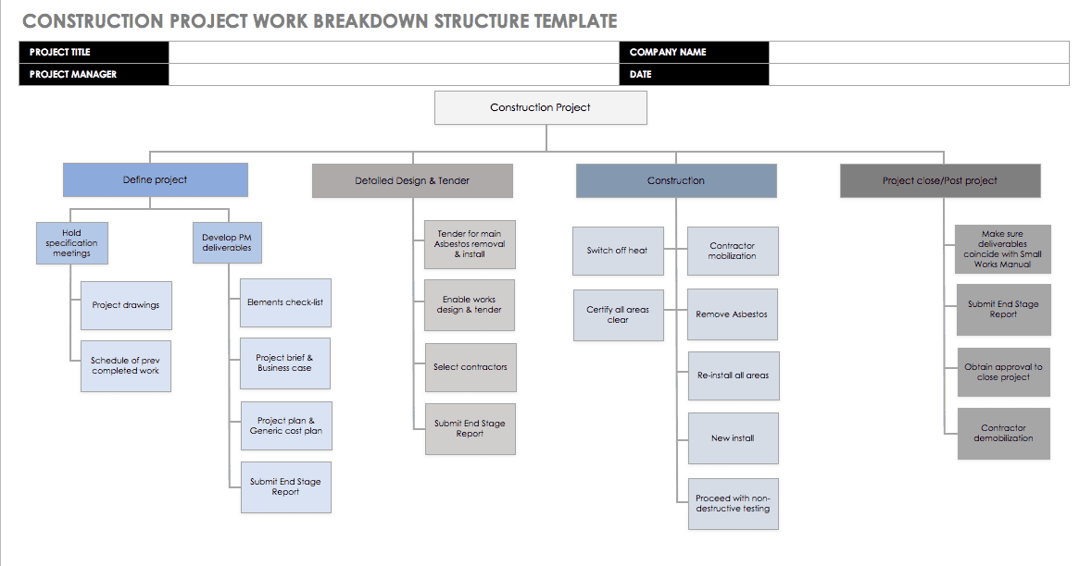

**Major steps in creating a WBS for a building project**

* Gather all available information on the construction project. This information will vary, depending on the project’s level of refinement, and might include drawings, engineering studies, pre-design work, or proposals.
* Set the goal. That is what are you building? Say HRT Towers along Kampala Road. Plot 6.
* Decide whether a deliverable-oriented or phase-based WBS is better for your goal.
* List the major deliverables according to either their construction phase or their structural system. These deliverables include milestones and processes.
* Divide each of these deliverables into components until you reach individual portions of work. You must be able to define, manage, estimate, and measure these work packages.

**PROJECT SCHEDULE**

A *project schedule* is a timetable that arranges tasks, resources and due dates in an ideal sequence so that a project can be completed on time. A project schedule is created during the planning phase and includes the following:

* A project timeline with start dates, end dates and milestones
* The work necessary to complete the project deliverables
* The costs, resources and dependencies associated with each task
* The team members that are responsible for each task

Project Schedule Steps-*The steps to create a project schedule include*:

* Create the schedule plan for your project
* Define who has authority over the schedule
* Identify start and end dates for project activities and tasks
* Figure out task dependencies
* Sequence activities and tasks chronologically to create a project calendar
* Estimate needed resources and resource availability
* Determine duration of activities and tasks
* Build project schedule
* Monitor and control the schedule throughout the project life cycle

Project scheduling occurs during the planning phase of the project life cycle. When beginning to put together a schedule for your project, you should ask yourself four things to start:

* What needs to be done?
* When will it be done?
* Who will do it?
* Where will it be done?

The answers to these four questions will greatly inform your project schedule moving forward, as you’ll use this information to plan start and end dates, link activities, set the duration, create milestones and manage resources.

**Follow these steps to create your own project schedule**

* Create a project scope. This is a document that contains the specific goals, deliverables, features, budget, of your project. All the tasks needed to complete the project successfully are listed here.
* Establish a sequence of tasks. Tasks are the small jobs that lead to the final deliverable, and it’s crucial to map out the sequence of those tasks before diving into them. You don’t want to get halfway through a task before you realize you can’t complete it due to hanging objectives.
* Group Tasks. Once you’ve collected your tasks and have them in proper order, you should take the opportunity to divide your tasks by importance.
* Find the critical path. You need to know which is critical to the project implementation schedule and must be done first and those less important that can be done later. This allows you to make smart choices about tasks that can be ignored if time and costs become constrained.
* Assign Resources. Resource management and project scheduling are closely related. Every task on your schedule should have the related resources and costs associated with completing it. With resources attached to tasks, you can more accurately plan your team’s time and keep their workload balanced.
* Adjust Plan. Schedules are living documents. As internal and external forces play on a project, you need a fast and easy way to adapt. Being flexible helps you avoid missing a deadline.
* Keep Stakeholders in the Loop. Stakeholders are the people with a vested interest in the project. They need to know what’s happening and keeping them informed of your project progress is one of your key responsibilities.

**Cost Planning**

Cost planning is the provision of a detailed and precise list of all costs needed for a construction project. It relies on cost estimates and utilizes the existing cost estimates as a baseline.

**A Cost Plan**

A cost plan is a document that breaks down the various elements of a construction project and provides detailed cost estimates for each component. This includes costs related to materials, labor, equipment, and other expenses associated with the project. ***Cost estimation*** *is the preliminary estimate of the total construction cost that occurs at the early stages of pre-construction phase of a building project. It is based on the analysis of the project scope, goals, design and other specifications.* A cost plan is typically structured in a way that allows for easy tracking and updating of costs throughout the project's duration. It serves as a valuable reference for all parties involved in the project, including clients, architects, engineers, contractors, and subcontractors.

Cost plans are typically developed during the design and pre-construction phases, with updates occurring at various stages as shown below:

* Concept Design Stage: An initial cost plan is created based on preliminary project specifications and scope.
* Detailed Design Stage: As the design is refined and more information becomes available, the cost plan is updated to reflect the changes.
* Tender Stage: Once the project has been tendered and contracts are awarded, the cost plan is updated to include contractor pricing.
* Construction Stage: The cost plan is continually updated throughout construction to track actual costs against the estimates, allowing for adjustments as needed.

***Individual assignment. What are the benefits of a cost plan***

**CONSTRUCTION COST REPORTING**

**Construction Cost Reporting** is a process of informing clients and other parties about the predicted or current actual costs of the project. This is done with the help of a tool known as a construction cost report. A ***Construction Cost Report*** is essentially the ledger/record book of a construction project. It captures, in meticulous detail, a construction endeavor’s financial ins and outs.  It provides a clear view of where every penny has been spent and forecasts where the remaining budget will be directed.It narrates the journey of a project from a fiscal perspective. Is the project sticking to its budgetary guidelines? Are there unexpected expenses that need addressing?

**Importance of Cost Reporting in Construction**

* Cost reporting helps project managers maintain a firm grip on the project’s finances. By monitoring the inflow and outflow of funds, they can ensure that the project remains within its budgetary limits.
* With historical data and current financial status, stakeholders can predict future expenditures, allocate resources more effectively, and spot potential economic challenges before they snowball into major issues.
* Cost reporting acts as the magnifying glass, highlighting areas where funds might be seeping out unnecessarily. By identifying these inefficiencies early on, corrective measures can be taken promptly.
* Transparency is the currency of trust in the construction realm. When investors, clients, and other stakeholders see a project’s financial health, it fosters confidence and cement relationships for future collaborations.
* Construction cost reports create a data chain of budgetary concerns, transactions, and adjustments.
* They are especially useful in proving regulatory compliance.
* With each cost report, everyone involved in a project not only receives an update on the financial status of the project, but they also ensure that each person is looking at the same numbers.
* Depending on the level of detail, construction cost reports can help decision makers assess risk, adjust expenses, and track various details of the project.
* They are vital to balancing contingency plans with scaling.

**Components of a Construction Cost Report**

**These detail what to be included in the construction cost report.**

**Project Details**:

* Name of the Project-HRT Towers.
* Location-Kampala Road, Plot 6. Kampala, Uganda.
* Description of the Project-Briefly give an overview of the project scope.
* Start and Expected Completion Dates.

**Group Assignment. In groups of 5 max, define the following.**

* An avenue.
* A rise.
* A boulevard.
* A street.
* A close.
* A lane.
* A crescent.

**Financial Overview**

The financial overview provides the monetary blueprint for the construction’s journey, ensuring every step is taken with monetary clarity. It entails:

* **Total Project Budget:** This is the ceiling of your spending, derived from initial estimations and agreed upon by stakeholders.
* **Amount Spent to Date:** This reflects the expenses incurred from the project’s onset to the present, offering a real-time glimpse into the funds utilized.
* **Estimated Cost to Complete:** This is the projected expenditure required to complete the project based on current trends and foreseeable expenses.

**Breakdown of Costs:**

* **Direct Costs:** These directly contribute to the construction:
* **Labor:** The hands that mold, construct, and bring the project to life. This includes wages, overtime, benefits, and other related expenses.
* **Materials:** The bricks, cement, steel, and more forming the physical backbone of the project.
* **Equipment:** Every tool and machinery, from towering cranes to humble hammers, aids in the construction process.
* **Subcontractors:** Specialized entities roped in for specific tasks that need expert handling, such as electrical fittings or plumbing.
* **Indirect Costs:** These indirectly contribute to the construction
* **Overheads:** Costs of running the project, like site maintenance, security, utilities, and temporary facilities.
* **Insurance:** Safeguarding the project against unforeseen mishaps to avoid losses. **Individual assignment.** *State any* ***five insurance companies*** *in Kampala that provide insurance for construction projects.*
* **Permits and Licenses:** Necessary legal clearances, ensuring the project aligns with regional rules and regulations.
* **Administration:** The expenses to manage the workforce, paperwork, and overall project logistics.

**Progress Comparison:**

Enter the “Progress Comparison” section of the Construction Cost Report—a veritable map detailing the journey thus far and what remains to be charted. It entails:

* Budgeted vs. Actual Expenditure-Comparing the two reveals if you’re on track, ahead, or lagging in financial terms.
* Work Completed vs. Work Remaining-Gauging these metrics provides a tangible sense of progress, highlighting areas of efficiency and zones requiring attention.

***Group Assignment-In groups of not more than 5 members.***

1. What are the steps taken in creating a Construction Cost Report?
2. What are the common mistakes made during construction cost reporting?
3. How can you improve construction cost reporting?

***Presentations are to be done in two weeks.***