**SWOT ANALYSIS**

SWOT analysis is a [framework](https://www.techtarget.com/whatis/definition/framework) for identifying and analyzing an organization's strengths, weaknesses, opportunities and threats. These words make up the SWOT acronym.

The primary goal of SWOT analysis is to increase awareness of the factors that go into making a business decision or establishing a business strategy. To do this, SWOT analyzes the internal and external environment and the factors that can impact the viability of a decision.

The SWOT framework is credited to Albert Humphrey, who tested the approach in the 1960s and 1970s at the [Stanford Research Institute](https://www.techtarget.com/whatis/definition/SRI-International-SRI). SWOT analysis was originally developed for business and based on data from Fortune 500 companies. It has been adopted by organizations of all types as a brainstorming aid to making business decisions.

### When and why should you do a SWOT analysis?

SWOT analysis is often used either at the start of, or as part of, a [strategic planning](https://www.techtarget.com/searchcio/definition/strategic-planning) process. The framework is considered a powerful support for decision-making because it enables an organization to uncover opportunities for success that were previously unarticulated. It also highlights threats before they become overly burdensome.

SWOT analysis can identify a market niche in which a business has a [competitive advantage](https://www.techtarget.com/searchcio/definition/competitive-advantage). It can also help individuals plot a career path that maximizes their strengths and alert them to threats that could thwart success.

This type of analysis is most effective when it is used to pragmatically recognize and include business issues and concerns. Consequently, SWOT often involves a diverse [cross-functional team](https://www.techtarget.com/searchcio/definition/crossfunctional) capable of sharing thoughts and ideas freely. The most effective teams would use actual experiences and data -- such as revenue or cost figures -- to build the SWOT analysis.

**Use a SWOT analysis to grow your business.**

* A SWOT analysis is a compilation of your company’s strengths, weaknesses, opportunities and threats.
* The primary objective of a SWOT analysis is to help organizations develop a full awareness of all the factors involved in making a business decision.
* Perform a SWOT analysis before you commit to any sort of company action, whether you are exploring new initiatives, revamping internal policies, considering opportunities to pivot or altering a plan midway through its execution.
* Use your SWOT analysis to discover recommendations and strategies, with a focus on leveraging strengths and opportunities to overcome weaknesses and threats.

A SWOT analysis matrix is made up of these four elements.

### Elements of a SWOT analysis

As its name states, a SWOT analysis examines four elements:

* **Strengths**: Internal attributes and resources that support a successful outcome, such as a diverse product line, loyal customers or strong customer service.
* **Weaknesses**: Internal factors and resources that make success more difficult to attain, such as a weak brand, excessive debt or inadequate staffing or training.
* **Opportunities**: External factors that the organization can capitalize on or take advantage of, such as favorable export tariffs, tax incentives or new enabling technologies.
* **Threats**: External factors that could jeopardize the entity's success, such as increasing competition, weakening demand or an uncertain supply chain.

A SWOT [**matrix**](https://www.techtarget.com/whatis/definition/matrix) is often used to organize the items identified under each of these four elements. The matrix is usually a square divided into four quadrants, with each quadrant representing one of the specific elements. Decision-makers identify and list specific strengths in the first quadrant, weaknesses in the next, then opportunities and, lastly, threats.

Organizations or individuals doing a SWOT analysis can opt to use various SWOT analysis templates. These templates are generally variations of the standard four-quadrant SWOT matrix.

### **How to do a SWOT analysis**

A SWOT analysis generally requires decision-makers to first specify the objective they hope to achieve for the business, organization, initiative or individual. From there, the decision-makers list the strengths and weaknesses as well as opportunities and threats.

Various tools exist to guide the [decision-making process](https://www.techtarget.com/searchbusinessanalytics/definition/decision-making-process). They frequently provide questions that fall under each of the four SWOT elements.

For example, participants might be asked the following to identify their company's strengths: "What do you do better than anyone else?" and "what advantages do you have?" To identify weaknesses, they may be asked "where do you need improvement?" Similarly, they'd run through questions such as "what market trends could increase sales?" and "where do your competitors have market share advantages?" to identify opportunities and threats.

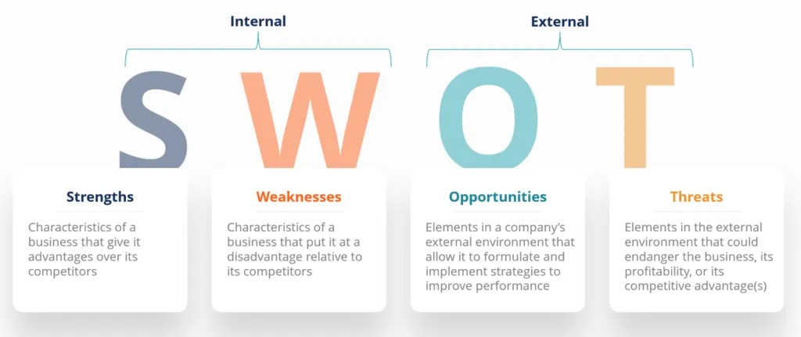

### **Example of a SWOT analysis**

The end result of a SWOT analysis should be a chart or list of a subject's characteristics. The following is an example of a SWOT analysis of an imaginary [retail employee](https://firsthand.co/professions/retail-sales-workers/about):

* **Strengths:** good communication skills, on time for shifts, handles customers well, gets along well with all departments, physical strength, good availability.
* **Weaknesses:** takes long smoke breaks, has low technical skill, very prone to spending time chatting.
* **Opportunities:**storefront worker, greeting customers and assisting them to find products, helping keep customers satisfied, assisting customers post-purchase and ensuring buying confidence, stocking shelves.
* **Threats:** occasionally missing time during peak business due to breaks, sometimes too much time spent per customer post-sale, too much time in interdepartmental chat.

### **How to use a SWOT analysis**

A SWOT analysis should be used to help an entity gain insight into its current and future position in the marketplace or against a stated goal.

Organizations or individuals using this analysis can see competitive advantages, positive prospects as well as existing and potential problems. With that information, they can develop business plans or personal or [organizational goals](https://www.techtarget.com/searchcio/definition/organizational-goals) to capitalize on positives and address deficiencies.

Once SWOT factors are identified, decision-makers can assess if an initiative, project or product is worth pursuing and what is needed to make it successful. As such, the analysis aims to help an organization match its resources to the competitive environment.

A SWOT analysis can be used to assess and consider a range of goals and [action plans](https://www.techtarget.com/whatis/definition/action-plan), such as the following:

* the creation and development of business products or services;
* making hiring, promotion or other human resources decisions;
* evaluating and improving customer service opportunities and performance;
* setting business strategies to improve competitiveness or improve business performance; and
* making investments in technologies, geographical locations or markets.

SWOT analysis is similar to PEST analysis, which stands for political, economic, social and technological. PEST analysis lets organizations analyze external factors that affect its operations and competitiveness.

### SWOT analysis pros and cons

Among the advantages of using a SWOT approach are the following:

* The analysis creates a visual representation of the factors that are most likely to impact whether the business, project, initiative or individual can successfully achieve an objective.
* By involving experienced cross-discipline team members, a SWOT analysis can encourage many different perspectives and approaches.
* Such diversity can allow a SWOT analysis to flesh out each element and expose creative ideas and overlooked problems that might otherwise go unnoticed.

Although a SWOT snapshot is important for understanding the many dynamics that affect success, the analysis does have limits, such as the following:

* The analysis may not include all relevant factors because some strengths, weaknesses, opportunities and threats can easily be overlooked or misunderstood.
* The input for each element can often be [empirical](https://www.techtarget.com/whatis/definition/empirical-analysis) or subjective and give a skewed perspective.
* Because it only captures factors at a particular point in time and doesn't allow for how those factors could change over time, the insight SWOT offers can have a limited shelf life.

**[Linda Tucci](https://www.techtarget.com/searchcio/tip/Free-IT-strategic-planning-templates-for-CIOs)**