**Construction Risk Management**

Construction risk management is the process of evaluating and implementing procedures to reduce the impact of risks in construction projects. This process entails thorough planning to create a risk management plan at the onset that allows project managers to identify, monitor and mitigate risks as they arise.

**The Construction Risk Management Process** involves the following steps:

* **Risk Identification:** This entails making a list of every possible risk that may arise. The list can be generated after risk research, a talk to the construction workers or historical data of previous construction projects.
* **Risk Assessment:** This is done because risks weigh differently whereby some are more likely to happen than others. The use of a risk matrix is of good help since it details the likelihood of each risk as well as its impact.
* **Risk Planning:** Once risks have been identified and prioritized based on their likelihood and potential impact, a construction risk management plan should be developed. This document details how risks will be managed throughout the construction project.
* **Risk Mitigation:** This stage entails implementing a strategy that will improve the impact of the risks you identified earlier once they occur. These strategies must be shared with the risk owner who will be responsible for ensuring risk mitigation.
* **Risk Monitoring:** This comprises of monitoring the effectiveness of your mitigation plan. It involves engaging several project stakeholders to help and empower the team to respond to risks.
* **Risk Reporting:** Your risk management construction plan should be analyzed and shared with the construction workers and stakeholders for a better evaluation of the effectiveness of the possibility plan.

***Group discussions: In groups of three, examine the possible construction risks and suggest ways to mitigate each risk mentioned.***

**Construction Risk Management Plan**

A construction risk management plan (CRMP) is a roadmap that defines the strategies and procedures to identify, assess and mitigate construction risks. This plan is vital in delivering a successful construction project.

**Construction Risk Management Plan Components**

**Construction Risk Register:** This detailed document outlines all the risk categories to consider for the construction project. It should also include a risk owner, risk response strategies and contingency planning if unforeseen circumstances arise.

**Construction Risk Matrix:** A construction [risk matrix](https://www.projectmanager.com/blog/risk-assessment-matrix-for-qualitative-analysis) is a visual tool that helps assess and prioritize potential risks in a construction project. It helps the team focus on the most important risks that could have a significant impact on the project’s budget, timeline or quality. A simple risk matrix is shown below.

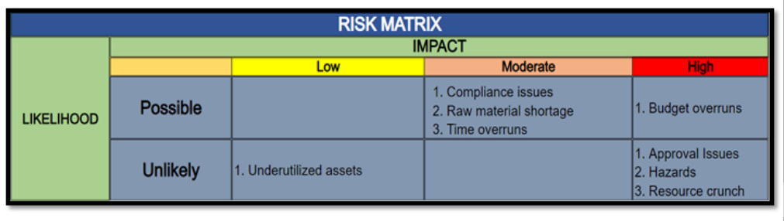**Risk Response Actions:** These are strategies used to help identify risks in a construction project to mitigate, transfer, avoid or accept the risk.

**Risk Management Team:** This team is responsible for communicating all information to relevant stakeholders to keep them informed of changes that may come along during the construction.

**Risk Budget:** This entails creating funds to cover unexpected costs or potential losses that arise from identified risks in a construction project.

**Key Risk Indicators:** Key risk indicators monitor and assess potential risks of the project in terms of finances, scheduling, quality, safety and legal matters. These key indicators must be trailed to address risks on time.

**Communication Plan:** A good communication plan allows all project stakeholders, including the project team, subcontractors, clients, suppliers and local community members to be on the same page.