Simulation modelling is a powerful tool in policy analysis because it allows policymakers to test the potential outcomes of different decisions before implementing them in the real world.

What Simulation Modelling Is in Policy Analysis
Simulation modelling uses computer-based models to replicate how a real-world system behaves. Policymakers can then adjust variables (like funding, regulations, or population growth) and observe the simulated outcomes.
This helps to:
- Predict short- and long-term impacts of policies.
- Compare different policy options.
- Identify unintended consequences before real implementation.

Example: Urban Traffic Deongestion Policy
Policy Problem:
A city faces rising traffic congestion, and policymakers are considering different interventions: building a new highway, introducing congestion charges, or improving public transport.
How Simulation Modelling Helps:
- Build the Model: A traffic simulation model is created using data on current traffic flows, road networks, public transport usage, and population growth trends.
- Test Scenarios:
  - Scenario A: Build a new highway.
  - Scenario B: Introduce congestion charges in the city center.
  - Scenario C: Invest heavily in public buses and metro systems.
- Simulated Outcomes:
  - Scenario A reduces congestion temporarily but increases car usage over time (“induced demand”).
  - Scenario B significantly cuts city-center congestion but shifts traffic to outer districts.
  - Scenario C reduces both congestion and pollution in the long run, though it requires higher upfront investment.
Policy Insight:
Simulation shows that building more roads may not solve the problem sustainably, while investing in public transport and/or congestion pricing is more effective in the long term.
Illustration:
Think of simulation modelling as a “virtual laboratory” for policies similar to a flight simulator for pilots. Policymakers can “fly through” possible futures and see what might work best without risking costly real-world failures.

A system model showing inputs → simulation Ouputs
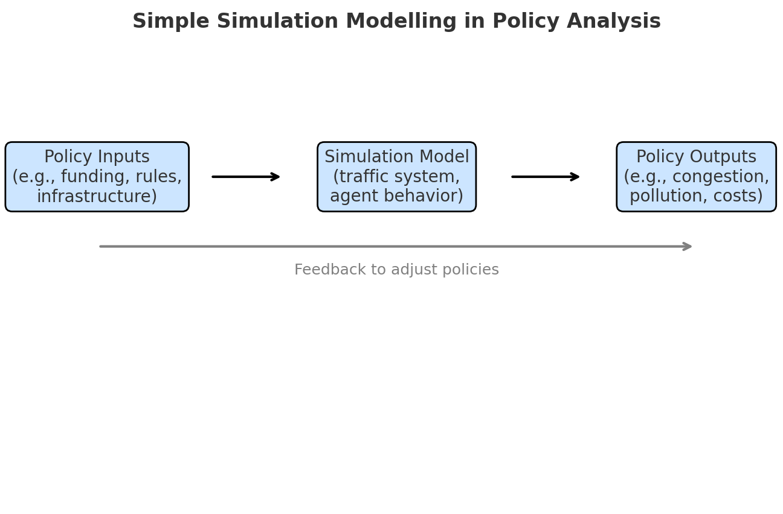
- Inputs (policy options) →
- Simulation Model (virtual system) →
- Outputs (predicted outcomes) →
- Feedback (to adjust policies).

