Conflict Management

The Importance and Benefits of Conflict Management
“Let’s just agree to disagree.”
‍I hate when people say that. Because it means they’ve given up. They’ve decided that their conflict is unresolvable. Conflicts at home and work often seem different, but they have similar roots — and similar remedies.
‍
Conflict is inevitable in any relationship, whether it be work-related or at home, but that doesn’t mean it is not unsolvable.
‍
Many managers fear conflict. They believe conflict is harmful, causing problems in the team and hurting people’s feelings.
‍
‍
Rather than stepping into an uncomfortable situation and engaging in difficult conversations, many managers avoid conflict altogether, allowing tensions to build.
‍
But it is the avoidance of conflict that causes the problem.
‍
When conflict is handled poorly, it takes control of your team. This unhealthy conflict is characterized by disrespect, refusal to compromise, anger, defensiveness and fear.
‍
‍
However, what if I tell you, that well-managed conflict becomes the key to effective communication in high-performing teams.
‍
When a manager understands how to manage conflict, team members are not afraid to disagree, challenge and question each other, all in the spirit of finding the best answer and making the best decision for the company/team.
‍
In other words, conflict should be embraced.
‍
Trusting one another to the point of debate and collaboration is the beauty of well-managed conflict and a key characteristic of high-performing teams.
‍
‍
This article will discuss the importance of well-managed conflict in an organization, its benefits, and the five conflict styles you should be embracing at your startup. Below, there will also be some tips on better conflict management.

What is Conflict Management?
‍Conflict management is the process by which disputes are resolved, where negative results are minimized, and positive results are prioritized.
‍
This critical management skill involves using different tactics such as negotiation, and creative thinking, depending on the situation.
‍
An organization can minimize interpersonal issues, enhance client satisfaction, and produce better business outcomes with adequately managed conflict.
‍
When done correctly, conflict management can increase a company’s organizational learning through truthful conversations.
‍
According to the Thomas-Kilmann Conflict Mode Instrument (TKI), used by human resource professionals worldwide. The Thomas Kilmann Conflict Mode Instrument begins by identifying the two basic dimensions of Conflict Behavior:
‍

Assertiveness:
‍
The degree to which you try to satisfy your concerns during a conflict.
‍
This is related to how you might try to meet your needs or receive support for your ideas.
‍

Cooperativeness:
‍
The degree to which you try to satisfy the other individuals’ concerns.
‍
It is related to how you might try to help the other individual meet their needs or how you can be receptive to the other individual’s ideas.
‍

The Importance of Conflict Management in Your Organization
‍
Many managers think that conflict can only be negative, that its result is only ever bad. In other words, they believe conflict is characteristic of poor team dynamics.
‍
This is entirely wrong.
‍
Conflict can be damaging, of course, and poorly managed becomes even worse, creating unhealthy team dynamics and showing signs that your team needs internal repair.
‍
But conflict, when managed successfully, brings many advantages to your team.
‍

Benefits of Effective Conflict Management

Teams cannot have effective communication without productive conflict.
‍
A manager’s goal should be to create an environment of well-managed conflict. An environment with psychological safety and vulnerability is crucial as a foundational step.
‍
Teams that trust one another are not afraid to engage in passionate dialogue around issues and decisions that are key to the organization’s success.
‍
When conflict is managed effectively, team members see conflict as a tool to exchange ideas while allowing each party to be equally heard.
‍
"Teams cannot have effective communication without productive conflict."
‍
Adequately managed conflict is an effective form of communication rather than a fearful argument.
‍
Under effective conflict management team members remain calm and non-defensive in their discussion of ideas. They seek to comprise and move past the issue to find an appropriate resolution.
‍
A well-managed conflict then has many benefits for your organization. With productive, well managed conflict, you will see the following:
‍
- Increased team performance, productivity, energy, and engagement.
- Improved leadership throughout the entire team.
- Greater innovation and creativity.
- Increased trust and connection among team members.
- Higher employee retention rates.
- Reduced employee stress and absence.
- Advanced workplace communication and collaboration.
‍

How to Address Different Conflict Styles
‍
We’ve thus far talked about how conflict can be the journey to truth, and that we must change our mindset on the benefits of conflict.
‍
But what about more difficult conflicts that don’t seem to get solved through straight talk, those that are deep-seated differences in values, principles, or approaches and seem too overbearing to deal with.
‍
We’re going to explore the other side of a conflict, and learn to effectively manage it so that we’re never left giving up by saying that we’re going to “agree to disagree.”
‍
Every relationship in every team in every workplace has conflicts. We disagree about big decisions — who to hire, how to improve culture, whether to let people keep working remotely. We also disagree about smaller issues — what time to meet and what to put first on the agenda.
‍
We’re going to explore different conflict styles as individuals and how they manifest, the benefits and cons of the styles.
‍
There are five major styles of conflict management — collaborating, competing, avoiding, accommodating, and compromising.

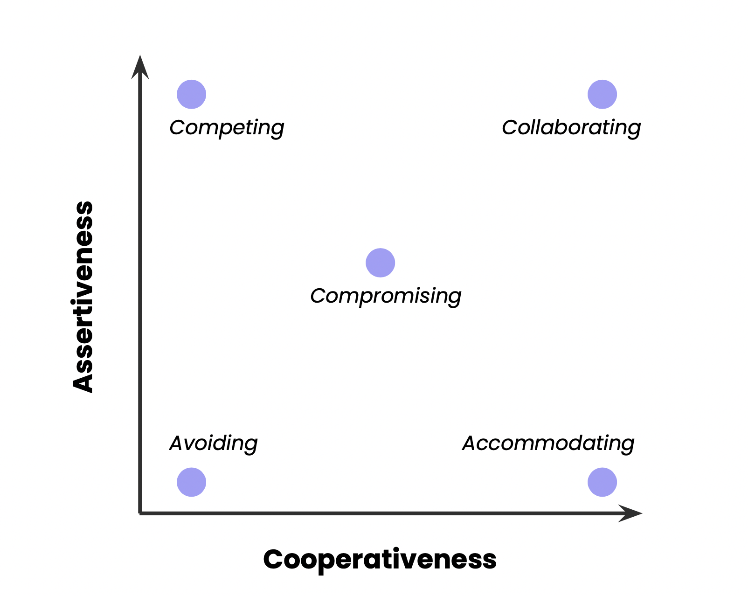
‍
- Competing
‍
Competing: Is assertive and uncooperative. In this mode, you try to satisfy your own concerns at the other person’s expense.
‍
A competing style takes a firm stance and refuses to see the perspectives of the other parties. You would keep pushing your viewpoint at others or rejecting their ideas until you get your way.
‍
This style could be appropriate when you have to stand up for your rights or morals, need to make a quick decision and force others to get on board, need to end a long-term conflict or have to prevent a terrible, opposing decision from being made.
‍
This style works when you don’t care about the relationship, and only the outcome is essential, such as when competing with another company for a new client.
‍
Don’t use competing inside your organization; it doesn’t build relationships.
‍

Benefits of Competing:‍
- Asserting your position: Allows you to stand up for your ideas and interests while ensuring they are taken seriously.
- Possibility of quick victory: Allows you to make a quick recommendation and possibly press for a quick decision if you have enough power to be victorious.
- Self-defence: Allows you to protect your interests and standpoints from attack.
- Testing assumptions: Allows you to debate to expose and test your own and others’ assumptions and views.
‍

Cons of Competing:‍
- Strained work relationships: The loser of the conflict may feel resentful or exploited.
- Suboptimal decisions: Rapid resolution can lead to possible win-win solutions being overlooked. Also, information is not exchanged freely in the Competing mode.
- Decreased initiative and motivation: When decisions are imposed, other individuals are less committed to them and show less initiative and motivation.
- Possible escalation and deadlock: It is possible there might be a temptation to use more extreme and provocative tactics if initial tactics fail. This can lead to a negotiation deadlock.
‍

When to Use It?‍
- Competing has a strong effect. It is best when used sparingly.
‍
- While it may be necessary and useful in quite a few situations, it also has the side effect of potentially imposing a significant cost on relationships and motivations. In its escalated form, it can be quite destructive.
‍
- According to Thomas, utilizing the competing mode is most appropriate in conflicts over very important issues when collaborating fails or is simply not feasible, and an assertive approach is required.
‍
- Situations can be: You may simply see an issue more clearly than others at times. This issue is critical to the organization’s (or individual’s) welfare. Other times a situation may require you to make an unpopular action, in which case you may need to use firmness to impose these decisions. Some examples of this may be enforcing budget cutbacks and enacting disciplinary actions or ending an individual’s employment.
‍

What Does Successful Competing Entail?
‍
- Thomas states that it is also essential to work on making sure that you fight fairly. Amid a discussion, you may be tempted to strengthen your position with exaggeration, which should be avoided as it will likely lessen your credibility now and on future issues.
‍
- Finally, work on switching to using caution instead of threats. Threats should be used as a last resort and with great care as they do a great deal of damage to any standing goodwill and promote defiance, counter-threats, and retaliation.
‍
- Avoiding
‍Avoiding: Is both unassertive and uncooperative. In this mode, you work to sidestep the conflict without attempting to satisfy either individual’s concerns.
‍
An avoiding style completely evades the conflict. You would neither pursue your beliefs nor those of the others involved. Simply, you would continuously postpone or completely dodge the conflict whenever it comes up.
‍

Benefits of Avoiding:‍
- Reducing stress: Allows you to avoid exacting or displeasing people and topics.
- Saving time: Allows you to not waste time and energy on low-priority items.
- Steering clear of danger: Allows you to avoid inciting trouble.
- Setting up more favourable conditions: Provides you with time to be more prepared and
- less distracted so that you may deal with the matter at hand.
‍

Cons of Avoiding:
- ‍Declining working relationships: Using this mode creates the possibility that work may not be accomplished as people avoid each other. Allows for hostile stereotypes to develop and putrefy.
- Resentment: Leads to resentment from others whose concerns are being neglected, seeing your actions as shifty.
- Delays: Unaddressed issues cause delays and may keep recurring. This takes up more time and causes more aggravation than if these problems were addressed earlier.
- Degrading communication and decision-making: Using this mode may cause people to walk on eggshells instead of speaking honestly and learning from one another.
‍

When is it best to Avoid?
- ‍The Avoiding conflict-handling mode is technically a lose-lose mode where the decision is made to not pursue your or the other individual’s concerns.
‍
- This may sound like a universally negative mode, but it is important to note that there are certain situations where the Avoiding mode can be the right decision.
‍
- According to Thomas, Avoiding is appropriate if it leads you to avoid “emotional” conflicts.
‍
- Emotional conflicts create defensiveness and hard feelings by personalizing the conflict. Start by avoiding issues of blame. Instead of focusing on those who showed poor judgment or didn’t do what they were supposed to, you can focus on how the process can be improved for future outcomes to be more successful.
‍
- Sometimes the most obvious time to use the Avoiding mode is when you need to find more time to handle a situation. If you are in the middle of a more critical issue, then the right course of action is often to postpone dealing with the new issue.
‍
- In other situations, you may need more time to gather information on an issue so that you don’t make an immediate but uninformed decision in a conflict situation.
‍

What Does Successful Avoiding Entail: Differentiating between Avoiding and Evading
‍
- Using the Avoiding mode can come off as evasive when the reasoning for your choice to avoid a situation is not made clear. It is essential to develop the right skills for this.
‍
- Regardless of your reasoning, you neglect the other person's concerns, even if it is temporary.
‍
- It is helpful to actively communicate why you are avoiding an issue to minimize the negative impact. It’s also beneficial to set a time for when the issue may be realistically addressed.
‍
- Accommodating
‍Accommodating: Is unassertive and cooperative. In this mode, you try to satisfy the other person’s concerns at the expense of your own concerns.
‍
The opposite of competing, there is an element of self-sacrifice when accommodating to satisfy the other person. While it may seem generous, it could take advantage of the weak and cause resentment.
‍
An accommodating style forsakes your own needs or desires in exchange for those of others. You would be putting the concerns of others before your own. This style usually occurs when you either simply give in or are persuaded to give in.
‍

Benefits of Accommodating:‍
- Helping someone out: Assisting others in meeting their needs by supporting them.
- Restoring harmony: Can smooth feathers and settle troubled waters.
- Building relationships: Can be used to build social capital by doing favours. It can also be used as a way of apologizing when necessary.
- Choosing a quick ending: This mode can be used to cut your losses as a way to minimize future losses in a hopeless situation.
‍

Cons of Accommodating:‍
- Sacrificed concerns: This mode entails conceding something you care about, so your views or interests are inevitably sacrificed.
- Loss of respect: This mode can build goodwill, but a perception of low assertiveness can lead to losing respect from your peers. A pattern of accommodating can encourage others to exploit you.
- Loss of Motivation: Using the Accommodating mode leads to less satisfaction. It can lead to you agreeing to things you have little excited about.
‍

When is it best to Accommodate?
- ‍A simple and appropriate time to use the Accommodating mode is after making a case for your personal position and hearing the other person’s thoughts. You simply decide that you are wrong or the other individual's position is better or stronger. At that point, admitting that you are wrong is the better option in the long run.
‍
- Thomas also writes Accommodating conflict-handling mode works when you realize that a small sacrifice on your part can do a much greater good for someone else. Whether it is simply doing someone a favour, boosting someone's confidence, or encouraging development by allowing the other person to make decisions even if you have doubts.
‍
- Accommodating can also be used as a way of damage control or a way to repair the damage you may have caused in a previous encounter by apologizing or making reparations.
‍

What Does Successful Accommodating Entail:
‍
- According to Thomas, one of the most valuable skills to develop when using the Accommodating mode is learning to concede gracefully.
‍
- The ability to not be a sore loser is a surefire way to earn respect. Don’t complain; instead, take the high road, as acting out will only lead others to view you in a more negative light.
‍
- The final skill set you can develop is learning how to satisfy a complaint. Complaints can often provide feedback that can help performance, but how you react makes a big difference in the outcome.
‍
- It is reasonable to accept anger as it often accompanies complaints, but there is a fine line between accepting anger and accepting abuse.
‍
- Allowing the other individuals to express themselves without being defensive or counterattacking allows the other individual to have their feelings heard and can often calm the situation until it can be discussed more reasonably.
‍
- Compromising
‍Compromising: Is intermediate in both assertiveness and cooperativeness. In this mode, you try to find an acceptable solution that only partially satisfies both individual’s concerns.
‍
A compromising style attempts to find a solution that will at least partially please all parties.
‍
You would work to find a middle ground between all the needs, typically leaving people unsatisfied or satisfied to a certain extent.
‍

Benefits of Compromising:‍
- Pragmatism: Often leads to a good deal without the necessary effort to get both parties everything they want.
- Speed and expediency Allows you to settle on a conclusion quickly.
- Fairness: Creates resolutions that aim for equal gains and losses for both parties.
- Maintaining relationships: Allows both parties to meet halfway and reduces strain on the relationship.
‍

Cons of Compromising:‍
- Partially sacrificed concerns: Since both individuals’ concerns are compromised, it leaves some residual frustration. The issue isn’t fully resolved and may flare up again.
- Suboptimal solutions: Settling for compromising decisions is of lower quality than successful collaborative decisions.
- Superficial understanding: Agreements often gloss over differences with fuzzy statements that don’t accurately mirror the beliefs of the individuals who disagree.
‍

When is it best to Compromise?‍
- Compromising solutions are often not the first go-to solution when dealing with conflict, but there are times that they are the most efficient and practical solutions to a problem.
‍
- Compromising is best suited for issues of intermediate importance to you, important enough to care about yet not critical.
‍
- When choosing to utilize the compromising mode, you should make sure that you both take turns bearing small costs.
‍
- Utilized when a temporary solution to a more complex issue is required. There may be a better time to come up with a permanent solution using a different model, but for the time being, the compromising solution allows for work to continue.
‍
- This mode is also used when two individuals with equal power are faced with a win-lose issue where collaboration is not working, and the competing mode is unlikely to be effective.
‍

What Does Successful Compromising Entail: Shifting from Competing to Compromising?‍
- One of the most complex behaviour skills to develop correctly is transitioning smoothly from competing to compromising mode, where you make partial concessions without giving away too much.
‍
- Giving away too much may give the inadvertent side effect of looking weak.
‍
- This is especially a problem if you begin to compromise while the other person is still competing.
‍
- Using “we” language is a good tactic that can help emphasize the need for compromise without appearing weak.
‍
- Once both parties are committed to compromising, your partial concessions must be reciprocated. You may need to discuss a few different partial concession options before one can be agreed upon.
‍
- Collaborating
‍
Collaborating: Is both assertive and cooperative. In this mode, you try to find a win-win solution that completely satisfies the concerns of both individuals involved.
‍
A collaborating style attempts to find a solution that will meet the needs of all parties.
‍
Rather than trying to find a middle ground solution, you would aim for a solution that actually satisfies everyone and ends up being a win-win situation.
‍

Benefits of Collaborating:
- High-quality decisions: Leads to seeking inventive solutions that are better than each person’s initial positions.
- Learning and communication: Aids communication and discovery through an open exchange of information.
- Resolution and commitment: Leads to both people working toward meeting all concerns, translating into both parties being committed to the decision.
- Strengthening relationships: Builds trust and respect by resolving problems in a relationship.
‍

Cons of Collaborating:
- Time and energy: Requires total concentration and creativity. It also requires more time for digging through issues than the other modes.
- Psychological demands: This can be psychologically demanding as both parties must be open to new viewpoints, ideas, and challenges.
- Possibility of offending: This mode may require working through some sensitive issues. You risk worsening the situation and potentially hurting others’ feelings if unsuccessful.
- Vulnerability risk: Others may try to exploit your flexibility and openness
‍

When is it best to Collaborate?‍
- Thomas states that Collaborating solutions are often highly desirable but are only really feasible when a situation meets very specific criteria.
‍
- More than any other mode, it requires ample time, participants to have strong interpersonal skills and trust for each other while being open to new ideas, and the issue itself needs to have integrative possibilities.
‍
- In this mode, you can test your assumptions without worrying about your energy defending your existing views, as we find in competitive arguments.
‍
- These individuals may be more challenging to manage because of the potential introduction of conflicting insight, but it also provides a way of garnering a more complete understanding of the situation at hand from the diversity of specialized perspectives.
‍
- The collaborative model can also be a proper choice when working through problems in a relationship, business or personal.
‍
- In any long-term relationship, unresolved issues can stack up as frustrations build-up from past accommodations and compromises. Collaborating can serve as a way to bring such matters to the surface socore problems can be resolved.
‍

What Does Successful Collaborating Entail? Engaging Others.‍
- A great place to start is working on setting the right tone when conflict issues arise. And doing it in such a way that doesn’t come off as being competitive or create defensiveness.
‍
- Thomas recommends utilizing “we” language to help create a collaborative environment once the timing is figured out, as it helps avoid blaming the other person. It focuses on solving a joint problem that can be solved together.
‍
- The second and most crucial step is identifying other individuals’ underlying concerns. To do this successfully, it is essential to learn how to effectively focus on each person’s concerns instead of their positions. The worries in a conflict are what each person cares about and is inherently threatened by the conflict.
‍
- Progressing to a position where both parties see the conflict as a mutual problem, you can focus on brainstorming solutions that would satisfy both of your concerns.
‍

Strategies for Better Conflict Management
‍
When embracing conflict and learning how to properly manage it, managers must understand the conflict continuum, from artificial harmony that becomes office politics and gossip to the mean-spirited conflict that is outright destructive.

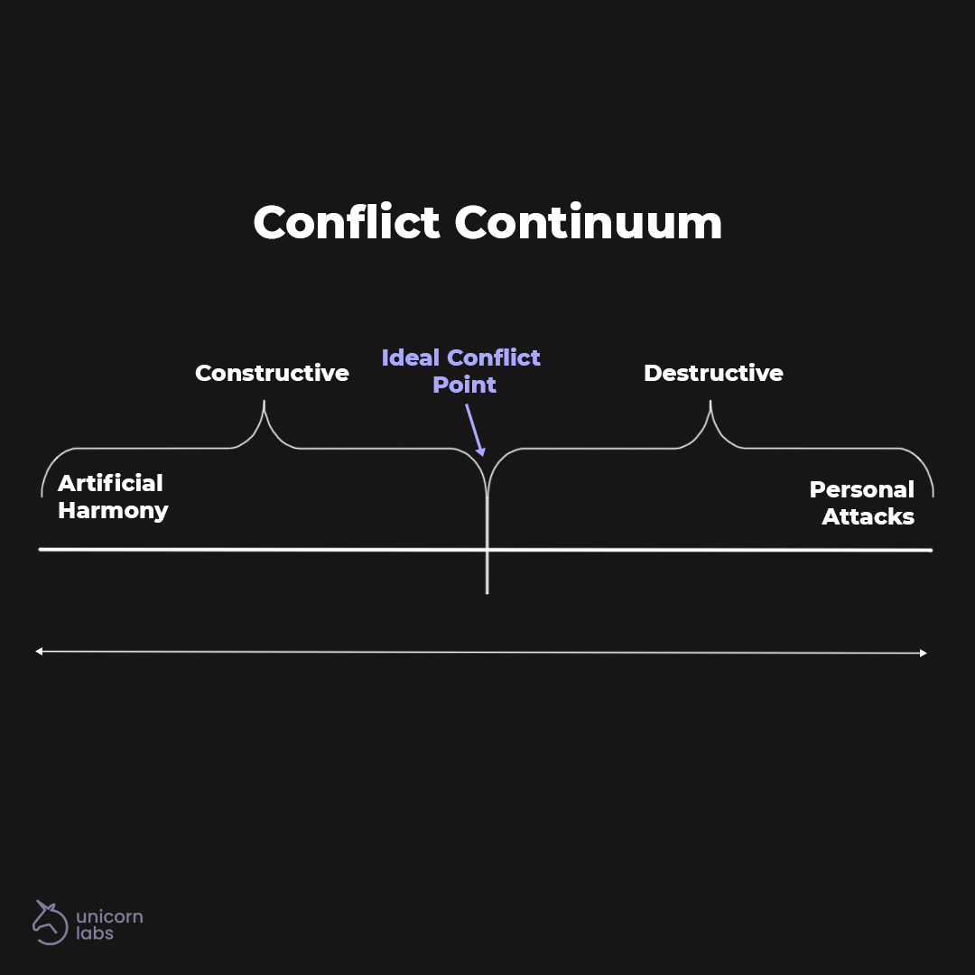

Artificial harmony is when people appear to be getting along, but they’re not connecting or understanding one another. Instead, they save face and act polite in front of each other, and gossip about one another at the water cooler.
‍
This is not the level you want your team to be operating on, as a team’s most significant potential can’t be achieved in an environment where people are afraid to step on each other's toes. There is no honesty in this kind of environment, and real innovative work can’t be achieved.
‍
On the other hand, the destructive conflict that comes from personal attacks and disrespect must also be avoided. This kind of conflict creates a toxic environment that lacks productivity, motivation, and employee engagement.
‍
To avoid the negative end of the conflict continuum, many managers avoid conflict altogether and end up close to the spectrum’s artificial harmony.
‍
But managers need to manage conflict in a way that puts their team closer to the center of the continuum, the ideal conflict point. At the perfect conflict point, you and your team will find the synergy you need to reach high levels of innovation and productivity.
‍
To get closer to the middle of the continuum, managers must encourage debate and dialogue around ideas and issues. Such as asking team members for feedback and encouraging them to voice their ideas and opinions on various discussion topics.
‍
Below you will find a few strategies to effectively manage conflict to find the ideal point of conflict on the conflict continuum.
‍

Understand Your Team’s Makeup
‍
Most often, negative conflict arises from misunderstandings and differing personalities butting heads.
‍As a manager, when you understand the various personalities on your team, you can better manage reactions and emotions when disagreements occur or prevent arguments from becoming toxic.
‍The best way to understand personalities is through that helps create a categorical understanding of typical patterns of individuals’ behaviours and emotions.
‍DISC will help you recognize each specified personality style’s characteristics, including your own, and help you and your teammates change your communication to meet other individuals’ needs on your team.
‍

