FORENSICS IN ACCOUNTING
This topic requires an understanding of three key terms: ‘forensic accounting’, ‘forensic investigation’ and ‘forensic audit’.
Forensic accounting is the branch of accounting that deals with the Prevention and detection of financial crimes. As a forensic accountant, you will use your competencies in accounting, auditing, and investigative techniques to detect and analyze cases of fraud and other financial crimes.
Forensic auditing is defined as the application of auditing skills to situations that have legal consequences. Auditors alert management on situations of control weaknesses, inadequacies in record keeping, errors and unusual transactions or results which could be indicative of fraud, improper or unlawful expenditure, unauthorised operations, waste, inefficiency or lack of probity.
Forensic accounting is the term used to describe the type of engagement. It is the whole process of carrying out a forensic investigation, including preparing an expert’s report or witness statement, and potentially acting as an expert witness in legal proceedings.
Forensic investigation is a part of a forensic accounting engagement. Forensic investigation is the process of gathering evidence so that the expert’s report or witness statement can be prepared. It includes forensic auditing, but incorporates a much broader range of investigative techniques, such as interviewing witnesses and suspects, imaging or recovering computer files including emails, physical searches of premises etc.
Forensic auditing is the application of traditional auditing procedures and techniques in order to gather evidence as part of the forensic investigation.

Application
The major applications of forensic accounting include fraud investigations, negligence cases and insurance claims.
An insurance claim would require determination of how much the client should claim from the insurer. The first step would be a detailed review of the insurance policy to determine ‘coverage’, i.e. what is insured and any clauses that might restrict the amount that can be claimed or invalidate the claim.
The second step would be to gather evidence to quantify the loss, i.e. the amount to be claimed. Insurance claims might include claims following misappropriation of assets, ie theft of goods or money. In such cases, the forensic accountant will review inventory or cash records and details of sales and purchases to reconcile the amounts held and determine the value of the goods or cash stolen. They will also test the reliability of the information held by counting a sample of inventory or cash currently held in comparison with the client’s records. The forensic accountant will not assume that there has been a theft; they will consider other possibilities such as an error in the data held.
Insurance claims may however, be much more complicated than this, such as in the case of business interruptions arising as a result of fire or flood. In these types of engagements the forensic accountant will review prospective financial information in comparison with reported outturn to evaluate the loss of profit arising as a result of the business interruption. The forensic accountant will not assume that there has been any loss of profit due to the business interruption; they will consider other possibilities such as a straightforward loss of market share to a competitor.
Forensic engagements often require the forensic accountant to quantify a loss. One such engagement is in professional negligence claims, ie when another accountant has breached their duty of care to a client or third party resulting in a loss for that client. In these types of engagement, the forensic accountant would also provide an opinion on whether the duty of care owed has been breached, ie whether the audit or other accountancy service was performed in accordance with current standards in practice, legislation and techniques. In relation to an audit, this would require consideration of whether the International Standards on Auditing were followed.
The need for a forensic accountant may also arise because two parties cannot agree on the amount owed by one party to another, and the accountant is engaged to provide an expert valuation, of a business for example.
This might be the case in a matrimonial dispute, where a divorcing couple whose assets include shares in a company or partnership, engage a forensic accountant to value the company so that a settlement can be reached. A similar process might apply in partnerships, when one partner wishes to leave the partnership and is being bought out by the remaining partner(s).

The role of an expert witness
An expert witness is quite different to any other witness in court proceedings. Most witnesses are 'witnesses of fact', i.e. they can only provide evidence on what they saw, did or heard. Most importantly, they cannot give their opinion on any of the matters about which they give evidence. By contrast, an expert witness is specifically called to give their opinion on a particular matter.
An accountant can be called to give evidence as a professional witness, i.e. a witness of fact, or an expert witness. In order to give evidence as an expert witness they must be just that, an expert. They must be able to demonstrate a level of expertise that means their opinion is valuable to the court. This means not only expertise in accountancy, but also expertise in the particular area of accountancy that they are giving evidence on.
A witness will provide a written report/statement to the court, and may also be required to attend court to give live evidence, in person, and be cross-examined by the ‘other side’.
However, not all forensic engagements will require evidence to be submitted to a court. Often, the engagement will simply require a report for the client’s own purposes or sometimes a report for use by the insurer.
Either way, a key skill necessary in being a successful forensic accountant is the ability to explain complex accounting concepts in simple terms to someone who is not themselves an accountant, whether that be as an expert witness explaining matters to the judge or jury, or when explaining matters to the client. Forensic accounting integrates investigative, accountancy, and communication skills.

Planning
Forensic accounting engagements are agreed-upon procedures engagements, not assurance engagements. The forensic accountant will not provide an assurance opinion – that is the role of the auditor when reviewing the amount of loss included in the financial statements.
This will normally involve determining an appropriate value or quantifying a loss as discussed above; this is quite distinct from an assurance engagement in which the engagement team would review an amount determined by the client.
As an agreed-upon procedures engagement, the forensic accountant will normally prepare a report for the client that sets out their findings, based on the scope agreed in the engagement letter. This report may be addressed to management, often in the case of a fraud, or to the insurer.
It may be that a witness statement/report for submission to the court/arbitrator is required in addition to or instead of a report to the client.
However, planning the investigation is likely to be similar to planning an audit or any other assurance engagement.
Planning will commence with a meeting with the client in which the engagement team will develop an understanding of the issue/events (the fraud, theft etc) and actions taken by the client since it occurred.
A key part of planning is to confirm exactly what format the output is required in, and exactly what matters are required to be covered within it.
At this stage any key documentation will be obtained and scrutinised – for example, the insurance policy, the partnership agreement, the evidence that led to the discovery of the fraud, etc.
The team will agree with the client, what access to other information or personnel will be required and this will be arranged.
Based on the above, the team will design procedures that enable them to meet the requirements of the client, as agreed. This may or may not include test of controls, depending on the circumstances. There would be no need to tests control when valuing a business for a matrimonial dispute. However, testing controls will be key to determining how a fraud took place.

Procedures and evidence
Any method of obtaining evidence can be used in a forensic accounting engagement – this is not a limited assurance engagement in which procedures are likely to be restricted to enquiry and analytical procedures.
Forensic engagements will include a detailed and wholesale review of all documentation and electronic evidence available. The opinion given by the expert accountant must be reasoned, and backed up by evidence. Their opinion cannot be objective if only based on what they are told; they must corroborate that information.
To be awarded marks in the exam, your procedures cannot be vague. They must be specific enough that the engagement team could actually follow your instructions.
For example, it would not be sufficient to write 'interview the suspect'. You must suggest questions that should be asked of the suspect in interview, depending on the circumstances in the scenario. For example, the suspect could be asked to explain their job role and what access that gives them to systems, cash, inventory etc.
This also applies when recommending enquires of or discussions with management – it must be clear in your answer what it is the engagement team should ask of them, eg have they informed the police, has the suspect been suspended, have they informed the insurer etc.
Equally it is not sufficient to suggest the use of computer assisted auditing techniques (CAATs). You must specify how the CAATs could be used. For example, data matching bank accounts used for paying suppliers with bank accounts for paying employees, exception reports identifying employees who are not taking holiday, etc.
In order to design appropriate procedures you must identify the type of forensic accounting engagement, and the specific type of fraud, insurance or negligence claim. For example, quantifying the theft of goods will be very different from quantifying a loss from payroll or ‘ghost employee’ fraud or loss of profits following a business interruption (as discussed above).

Fundamental ethical principles
The range of ethical and professional issues will be similar to any other type of engagement. However, the importance of ethics is arguably much greater in relation to forensic accountancy. Often both ‘sides’ will bring an expert witness to the hearing where they do not agree. The decision maker must decide which evidence they ‘prefer’ – the credibility of the witness is often the primary factor on which they can base that decision and the credibility of an accountant is reliant on their compliance with the fundamental ethical principles.
In the exam, you will also need to note whether the client requesting the forensic accounting service is an audit client, if so, this will present an additional and particularly important threat to objectivity; a self-review threat. The investigation is likely to involve the quantification of an amount, which will then be reviewed as part of the financial statements audit. The significance of the threat will be affected by the materiality of the amount and the subjectivity involved in quantifying it, eg if for loss of profits following business interruption this will be more subjective than quantification of the value of stolen inventory.
Remember that the decision to prosecute is a matter for the client. Often, clients do not want to prosecute for fear of damaging their reputation. The forensic accountant can provide the client with an analysis of all of the facts, but must not make the decision to prosecute (a management threat to objectivity). The forensic accountant has a duty of confidentiality, unless it is in the public interest to do so, they must not disclose the fraud to any third party including the police, without client permission.
Remember that a forensic accountant is just that; an accountant! Their role is to provide an accountant’s expert opinion or analysis of the facts. They are not the law-enforcer, prosecutor or judge. Be careful in the exam not to detract from an otherwise professional answer by getting carried away with suggestions such as taking fingerprints or DNA evidence or blood samples, or catching and punishing the culprit – that is not the role of an accountant.

Check your understanding
Question: Which of the following would be a valid procedure in a forensic engagement to determine the amount of insurance to be claimed in respect of lost profits during a business interruption following a flood?
- Obtain a written confirmation from the insurance provider to verify the amount of the loss.
- Recalculate management’s assessment of the loss to verify mathematical accuracy.
- Obtain the profit forecast for the period covered by insurance, and cast for mathematical accuracy.
Answer: The assurance provider’s role is to independently quantify the loss in order to determine the amount to be claimed; therefore 1 and 2 are not relevant. They would review the profit forecast in comparison with the actual outturn to determine the amount of profit lost and the first step would be to ensure that it adds up correctly. (Answer 3)
Question: Which of the following would be a valid statement to include in a witness statement from an expert witness, but not a professional witness?
- The company’s purchases daybook recorded 15 sales invoices made out in the name of the allegedly fictitious supplier.
- The majority of the transactions recorded in the sales day-book do not appear to be commercial in nature.
- 75% of customers breached the credit limits set by the company during the period.
Answer: 1 and 3 are a matter of fact, 2 is a matter of opinion. Only an expert witness can give their opinion. A professional witness is a witness of fact who can only comment on what they did, saw or heard. A professional accountancy witness could review a company’s records and comment on what they saw during that review. (Answer 2)

The need for forensic accountants
Forensic accountants are necessary for a variety of reasons. They can be useful for criminal investigations, litigation support, insurance claims, and corporate investigations.
Financial forensic engagements may fall into several categories. For example:
- Economic damages calculations, whether suffered through tort or breach of contract;
- Post-acquisition disputes such as earnouts or breaches of warranties;
- Bankruptcy, insolvency, and reorganization;
- Divorce settlement
- Securities fraud;
- Tax fraud;
- Money laundering;
- Business valuation;
- Credit card fraud;
- Skimming;
- Computer forensics/e-discovery; and
- Fraud risk assessments
Approach of conducting forensic investigations
Forensic accounting combines the work of an auditor and a public or private investigator. Unlike auditors whose goal is focused on finding and preventing errors, the role of a forensic accountant is to detect instances of fraud, as well as identify the suspected perpetrator of the fraud. Some of the most common types of fraud schemes include overstating revenues, understating liabilities, inventory manipulation, asset misappropriation, and bribery/corruption. To discover these, forensic accountants apply a variety of techniques.
Forensic accounting methods can be classified into quantitative and qualitative. The qualitative approach studies the personal characteristics of the individuals behind financial fraud schemes. A popular theory of fraud revolves around the fraud triangle, which classifies the three elements of fraud as perceived opportunity, perceived need (pressures), and rationalization. This theoretical construct was first articulated by behavioral scientist Donald Cressey. More recently, forensic accountants have gone beyond incentive effects and focused on behavioral characteristics, a branch of accounting known as accounting, behavior and organizations, or organizational behavior. Certain predictive factors, like being labeled as “narcissistic” or committing adultery, are common traits among fraud perpetrators. These characteristics are often not conclusive enough on their own to identify the culprit, but can help forensic accountants to narrow down a suspect list, sometimes based on behavioral or demographic factors.
The quantitative approach focuses on financial data information and searches for abnormalities or patterns predictive of misconduct. Today, forensic accountants work closely with data analytics to dig through complex financial records. Data collection is an important aspect of forensic accounting because proper analysis requires data that is sufficient and reliable. Once a forensic accountant has access to the relevant data, analytic techniques are applied. Predictive modeling can detect potentially fraudulent activities, entity resolution algorithms and social network analytics can identify hidden relationships, and text mining allows forensic accountants to parse through large amounts of unstructured data quickly. Another common quantitative forensic accounting method is the application of Benford's law. Benford's law predicts patterns in an observed set of accounting data, and the more the data deviates from the pattern, the more likely that the data has been manipulated and falsified.
Analytical techniques
Forensic accountants utilize an understanding of economic theories, business information, financial reporting systems, accounting and auditing standards and procedures, data management & electronic discovery, data analysis techniques for fraud detection, evidence gathering and investigative techniques, and litigation processes and procedures to perform their work.
When detecting fraud in public organizations accountants will look in areas such as billing, corruption, cash and non-cash asset misappropriation, refunds and issues in the payroll department. To detect fraud, companies may undergo management reviews, audits (both internally and externally) and inspection of documents. Forensic accountants will often try to prevent fraud before it happens but searching for errors and in-precise operations as well as poorly documented transactions.
The process begins with the forensic accountant gathering as much information as possible from clients, suppliers, stakeholders and anyone else involved in the company. Next, they will analyze financial statements in order to try and find errors or mistakes in the reporting of those financial statements as well as they will analyze any background information provided. The next step involves interviewing employees in order to try and find where the fraud may be occurring. Investigators will look at company values, performance reviews, management styles and the overall structure of the company. After this is complete the forensic accountant will try to draw conclusions from their findings.
Considerations in forensic auditing
Audit Planning: audits could be planned to cover only a selected sample of offices based on an analytical review of accounts and results of past audits instead of blanket coverage of all spending offices.
Scope of Audit: unless otherwise stipulated, audit should concentrate on regularity, probity and compliance issues. Performance related issues could be dealt with in specific performance reviews.
Reporting: Significant failures in the application of prescribed controls and enactment of administrative duties particularly in the areas of monitoring and stock verification at all levels, and the implications involved, must be clearly brought out.
Relationship with investigating agencies: The rules for requisitioning records by the investigative agencies should be clearly understood by the staff and middle level management in offices as well as in those of the investigative agencies.
Position of the Auditor in criminal investigations: There is a need to provide clear and binding instructions about the manner in which audit staff are required to provide information to the investigative agencies. Audit staff should not be questioned in a manner akin to that employed for suspects, audit staff may resent, and hence avoid, being involved in criminal proceedings. The possibility of auditors conniving in fraud has to be kept in view, it is necessary to ensure that unless there is prima facie evidence to this effect, the auditor must be a part of the investigative team.
Implications and uses of Information Technology: A thorough knowledge of IT and the engagement of highly skilled professionals is essential if Forensic auditing is to have any meaning. The ease with which data can be sorted, analysed and compared makes it much easier to identify suspect transactions either singly or as a group of similar or related ones, thus greatly facilitating forensic auditing. The availability of archived data and the ease of access also could assist forensic auditing. Data matching and data mining techniques offer excellent opportunities.
Training: It is necessary to provide formal instruction in fraud awareness, investigation and reporting. The planning of overall audit coverage and individual audits on the basis of risk analysis carried in accordance with existing global ‘best practice’ could be included in the curriculum for all management levels.

Applications of Forensic Audit
An obvious example of forensic auditing is the investigation of a fraud or presumptive fraud with a view to gathering evidence that could be presented in a court of law. It might be useful, to discuss forensic auditing as being either ’Reactive’ or ‘Proactive ‘.
- Proactive forensic auditing
It is the use of auditing skills to prevent fraud by identifying and rectifying situations which could lead to frauds being perpetrated (i.e. risks). Forensic auditing in this sense could be viewed from different aspects depending on its application.
Forensic audit methodologies can be used to obtain a more detailed understanding of the entity and its activities to identify areas of risk both in determining the direction of the audit and in expressing an opinion.
Forensic auditing can also be used either by management or by auditors to carry out general reviews of activities to highlight risks arising either out of fraud or from any other source with the purpose of initiating focussed reviews of particular areas, targeting specific threats to the organisation.
Complaints, allegations in the Press or in Parliament, anonymous tips from employees or others could all in their separate ways require to be adequately addressed by investigation. The techniques of forensic auditing are useful in such cases. This is being cited as proactive because it is widely felt that the existence of a system of investigation in such cases is a significant deterrent to fraud and corruption.
b) Reactive Forensic Auditing
The objective in case of reactive forensic audit is to investigate cases of suspected fraud so as to prove or disprove the suspicions, and if the suspicions are proven, to identify the persons involved, support the findings by evidence and to present the evidence in an acceptable format in any subsequent disciplinary or criminal proceedings.
In such cases it is important to keep in view the following:
- working relations with the investigating and prosecuting agencies
- authorisation and control of the audit investigation
- documentation of relevant information and safeguarding all prime records pertaining to the case
- rules of evidence governing admissibility/authentication of records
- confidentiality
- evaluation of the evidence to assess whether the case is sustainable
- legal advice where appropriate
- Reporting the findings in a manner that meets legal requirements.
Management involvement
Audits are carried out and reported within a framework which assumes that the top management both at the political and civil service levels are responsive to the need for good governance and accountability.
Management should act upon the audit findings which indicate that there was cause for concern in the adequacy and implementation of internal controls, and inevitably institute enquiries into instances indicative of illegal action on the part of officials.
There is a need to provide a comprehensive framework involving the use of Forensic auditing methodology, particularly in the areas of audit planning and execution, and for a uniform reporting practice that would very explicitly spell out the implications of control failures including failure of senior management in implementing prescribed controls.

Conducting investigation interviews
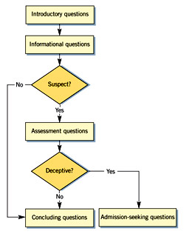

Steps involved in interviewing
- Prepare; Before asking the first question, spend time reviewing documentation such as checks, invoices and ledgers, personnel files and other information such as witness statements. Jot down the key areas you want to explore.
- Think as you go; don‘t write before the interview because writing the questions is limiting; if something comes up during the interview that's not on your list of questions, you're likely to overlook it. Instead, refer to your key-points list.
- Watch nonverbal behavior; observe how someone reacts to easy questions, and then measure the differences—if any—when the questioning gets tougher. This process is called calibration and is an integral part of assessing a witness's truthfulness.
- Set the tone; create the proper impression, enlist the person's cooperation and explain the nature of your inquiry.
- Pace your questions; Let the interview flow naturally, progressing from the easy to the tough questions, establish a rapport with the person.
- Do more listening than talking; interviewing is a two-way street; you must give information to get it.
- Be straightforward; approach interviews in an honest and open way. Do not become withdrawn and defensive.
- Take your time; trust your instincts and keep pressing in a nice way for answers. However, the longer the interview lasts, the more likely the contradictory statements.
- Double-check the facts; take a few extra minutes before the end of the interview to make sure you have the story right.
- Get it in writing; to avoid wrongful accusations, don't confront your subject unless you are convinced you have enough evidence to prove your case even without a confession. There is usually no more powerful evidence of wrongdoing than a person affixing his or her own signature to a written confession.
FRAUD REPORT WRITING
The process of documenting the details of a fraud investigation begins with an understanding of who is going to read it.
Parts of a Fraud Report
- Forwarding letter
- Disclaimer
- Table of contents
- Table of abbreviations
- Synopsis / executive summary; the synopsis summarizes only the most salient facts. The reader should not have to examine the entire document in order to understand what it is about. Managers and attorneys especially prosecutors should be able to quickly read the key elements of the investigation to grasp the issues involved.
- Detailed chapters
- Index to the report; an index of interview memoranda, exhibits and visual aids follows the synopsis. If the report is less than 10 pages long, an index usually is optional.
- Memoranda of interviews; a memorandum sets forth the key information furnished by a witness. The report writer should list the memoranda in the order in which he or she conducted the interviews. In this way, the reader can easily follow the investigation as it progresses from one witness to the next.
- Visual aids; visual aids help the reader understand the case. They are especially helpful when there are multiple witnesses, events or other complex relationships involved. In addition to financial statement graphs, some of the visual aids commonly used include time flow diagrams.
Standards for Writing Fraud Reports
Fraud reports are used as a basis for litigation and prosecution. Accordingly, they should adhere to five standards.
- Accuracy; the fraud report must be accurate, devoid of mistakes in dates, amounts, spelling or even in recording the most seemingly unimportant facts or details. Carelessness leaves the entire report open to question and criticism.
- Clarity; Use clear language not subject to various interpretations.
- Impartiality; do not add bias or foregone conclusions. Avoid expressing opinions—let the facts speak for themselves and let others interpret them.
- Relevance; in every investigation the fraud examiner uncovers facts not relevant to the case; he or she should exclude such information.
- Timeliness; fraud examiners should prepare reports during the course of the investigation and not long after the fact. An investigator who does not prepare a report on a timely basis runs the risk of omitting or distorting important data.

Financial crimes
Financial crimes encompass a wide range of illegal activities involving financial institutions, markets, and transactions, with the primary goal of obtaining financial gain. These crimes include fraud, money laundering, terrorist financing, bribery, and insider trading, among others.
Types of Financial Crimes:

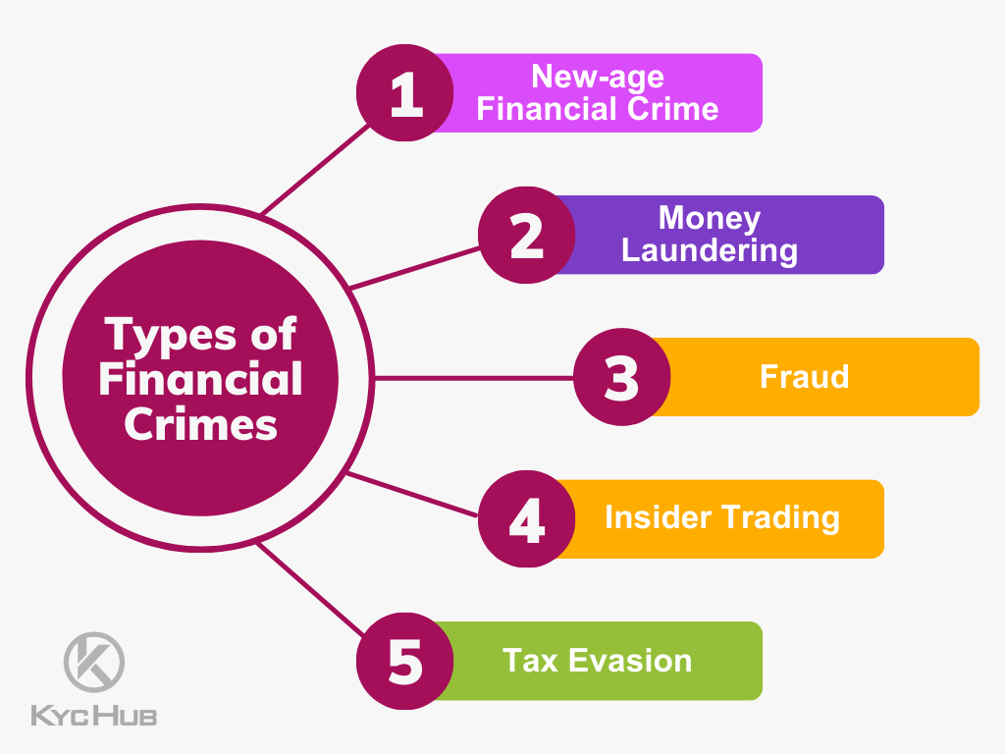
Fraud: This involves deceiving others for financial gain, including schemes like identity theft, investment scams, and mortgage fraud.
Money Laundering: This is the process of concealing the origins of illegally obtained money to make it appear legitimate.
Terrorist Financing: This involves providing financial support to terrorist organizations or activities.
Bribery and Corruption: This includes offering or accepting bribes to influence decisions or actions, often in business or government contexts.
Insider Trading: This involves using non-public information to make financial gains in the stock market.
Cybercrime: This encompasses a wide range of online financial crimes, including hacking, phishing, and online fraud.
Tax Evasion: This involves illegally avoiding paying taxes.
Embezzlement: This occurs when someone entrusted with money or property misappropriates it for personal gain.
Market Manipulation: This involves artificially influencing the price of securities or other assets to deceive investors.
Counterfeit Money: This involves creating or possessing fake currency.
Insurance Fraud: This involves making false claims or engaging in deceptive practices to obtain insurance payments.
Mortgage Fraud: This involves making false statements or omissions on a mortgage application to obtain a loan.

