COURSE NAME: INFORMATION & COMMUNICATION TECHNOLOGY
COURSE CODE: DCH1104
PROGRAM: DIPLOMA IN CATERING AND HOTEL OPERATIONS
YEAR: I
SEMESTER: I
CREDIT UNITS: 4
ACADEMIC YEAR: 2023/2024

ICT NOTES

What is Computer?
A computer is a programmable electronic device that accepts raw data as input and processes it with a set of instructions (a program) to produce the result as output.
The basic parts without which a computer cannot work are as follows:
- Processor: It executes instructions from software and hardware.
- Memory: It is the primary memory for data transfer between the CPU and storage.
- Motherboard: It is the part that connects all other parts or components of a computer.
- Storage Device: It permanently stores the data, e.g., hard drive.
- Input Device: It allows you to communicate with the computer or to input data, e.g., a keyboard.
- Output Device: It enables you to see the output, e.g., monitor.
The computer has become a part of our life. There are plenty of things that we do in a day are dependent on a computer. Some of the common examples are as follows:
- ATM: While withdrawing cash from an ATM, you are using a computer that enables the ATM to take instructions and dispense cash accordingly.
- Digital currency: A computer keeps a record of your transactions and balance in your account and the money deposited in your account in a bank is stored as a digital record or digital currency.
- Trading: Stock markets use computers for day to day trading. There are many advanced algorithms based on computers that handle trading without involving humans.
- Smartphone: The smartphone that we use throughout the day for calling, texting, browsing is itself a computer.
- VoIP: All voice over IP communication (VoIP) is handled and done by computers.

Software
- Software, which is abbreviated as SW or S/W, is a set of programs that enables the hardware to perform a specific task. All the programs that run the computer are software. The software can be of three types: system software, application software, and programming software.

System Software
- The system software is the main software that runs the computer. When you turn on the computer, it activates the hardware and controls and coordinates their functioning. The application programs are also controlled by system software. An operating system is an example of system software.

i) Operating System:
- An operating system is the system software that works as an interface to enable the user to communicate with the computer. It manages and coordinates the functioning of hardware and software of the computer. The commonly used operating systems are Microsoft Windows, Linux, and Apple Mac OS X.
- Some other examples of system software include:
- BIOS: It stands for basic input output system. It is a type of system software, which is stored in Read Only Memory (ROM) located on the motherboard. However, in advanced computer systems, it is stored in flash memory. BIOS is the first software that gets activated when you turn on your computer system. It loads the drivers of the hard disk into memory as well as assists the operating system to load itself into the memory.
- Boot Program: Boot refers to starting up a computer. When you switch on the computer, the commands in the ROM are executed automatically to load the boot program into memory and execute its instructions. The BIOS program has a basic set of commands that enables the computer to perform the basic input/output instructions to start the computer.
- An assembler: It plays the role of a converter as it receives basic computer instructions and converts them into a pattern of bits. The processor uses these bits to perform basic operations.
- A device driver: This system software controls hardware devices connected to a computer. It enables the computer to use the hardware by providing an appropriate interface. The kernel of a Computer's CPU communicates with different hardware through this software. Operating systems generally come with most of the device drivers. If the operating system does not have a device driver for hardware, you have to install the device driver before using that hardware device.

Application Software:
- Application software is a set of programs designed to perform a specific task. It does not control the working of a computer as it is designed for end-users. A computer can run without application software. Application software can be easily installed or uninstalled as required. It can be a single program or a collection of small programs. Microsoft Office Suite, Adobe Photoshop, and any other software like payroll software or income tax software are application software. As we know, they are designed to perform specific tasks. Accordingly, they can be of different types such as:
- Word Processing Software: This software allows users to create, edit, format, and manipulate the text and more. It offers lots of options for writing documents, creating images, and more. For example, MS Word, WordPad, Notepad, etc.
- Spreadsheet Software: It is designed to perform calculations, store data, create charts, etc. It has rows and columns, and the data is entered in the cell, which is an intersection of a row and column, e.g., Microsoft Excel.
- Multimedia Software: These software are developed to perform editing of video, audio, and text. It allows you to combine texts, videos, audio, and images. Thus, you can improve a text document by adding photos, animations, graphics, and charts through multimedia software. For example, VLC player, Window Media Player, etc.
- Enterprise Software: These software are developed for business operational functions. It is used in large organizations where the quantum of business is too large. It can be used for accounting, billing, order processing and more. For example, CRM (Customer Relationship Management), BI (Business Intelligence), ERP (Enterprise Resource Planning), SCM (Supply Chain Management), customer support system, and more.

Operating System can be defined as an interface between user and the hardware. It provides an environment to the user so that, the user can perform its task in convenient and efficient way.

Operating System Definition and Function
In the Computer System (comprises of Hardware and software), Hardware can only understand machine code (in the form of 0 and 1) which doesn't make any sense to a naive user.
We need a system which can act as an intermediary and manage all the processes and resources present in the system.
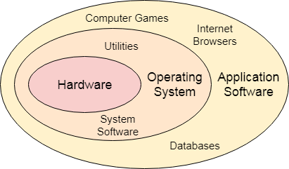
An Operating System can be defined as an interface between user and hardware. It is responsible for the execution of all the processes, Resource Allocation, CPU management, File Management and many other tasks.
The purpose of an operating system is to provide an environment in which a user can execute programs in convenient and efficient manner.

Structure of a Computer System
A Computer System consists of:

- Users (people who are using the computer)
- Application Programs (Compilers, Databases, Games, Video player, Browsers, etc.)
- System Programs (Shells, Editors, Compilers, etc.)
- Operating System ( A special program which acts as an interface between user and hardware )
- Hardware ( CPU, Disks, Memory, etc)
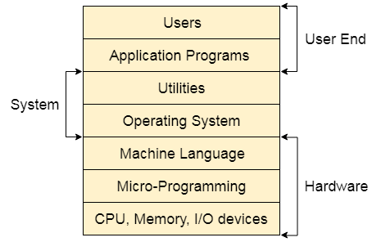

What does an Operating system do?
- Process Management
- Process Synchronization
- Memory Management
- CPU Scheduling
- File Management
- Security

Accessed from:
https://www.javatpoint.com/what-is-computer

