RISKS AND RISK MANAGEMENT

What is risk?
- Risk means uncertainty that may result in an adverse outcome, adverse in relation to planned objectives.
- A risk can be defined as an unplanned event with financial consequences resulting in loss or reduced earnings
- Risk stems from uncertainty or unpredictability of the future.
- In commercial and business activities, risk generates profit or loss depending upon the way in which it is managed.

What is risk management?
- Risk management is a central part of any organization’s strategic management. It is the process whereby organizations methodically address the risks attaching to their activities with the goal of achieving sustained benefit within each activity and across the portfolio of all activities.
- The focus of good risk management is the identification and treatment of these risks. Its objective is to add maximum sustainable value to all the activities of the organization.

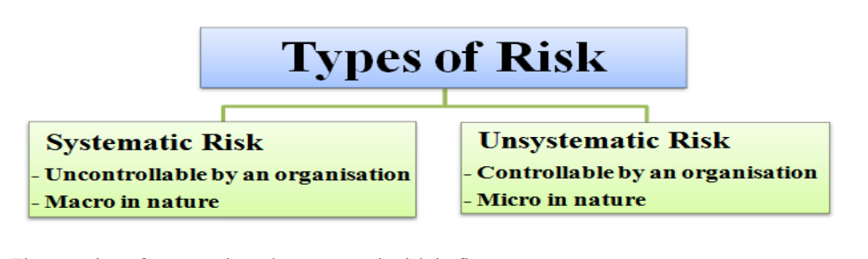

Systematic risks;
- Systematic risk can be defined as a type of total risk that arises due to the influence of various external factors on an organization. E.g economic factors like movements in interest rates
Such factors are normally uncontrollable from an organization’s point of view.
This risk is macro in nature as it affects a large number of organizations operating under the same domain.
Examples
- Interest rate risk
- Market risk
- Inflationary risk

- Interest rate risk

What is Interest Rate Risk?
- Interest rate risk is the risk where changes in market interest rates might adversely affect a bank’s financial condition.

- The management of Interest Rate Risk should be one of the critical components of market risk management in banks.
- The regulatory restrictions in the past had greatly reduced many of the risks in the banking system. Deregulation of interest rates has, however, exposed them to the adverse impacts of interest rate risk.

What is the Impact of IRR?
The immediate impact of changes in interest rates is on the Net Interest Income (NII).
A long-term impact of changing interest rates is on the bank’s net worth since the economic value of a bank’s assets, liabilities and off-balance sheet positions get affected due to variation in market interest rates.

- Market risk
- This can be defined as the risk of losses in the bank’s on and off-balance sheet positions that arises from movement in market prices e.g., equity/stock prices, foreign exchange rates, commodity prices etc.
- Market risk is prevalent mostly amongst banks who are into investment banking since they are active in capital markets.

Unsystematic risks
Unsystematic risk is due to the influence of internal factors prevailing within an organization.
- Such factors are normally controllable from an organization's point of view. It is a micro in nature as it affects only a particular organization. It can be planned, so that necessary actions can be taken by the organization to mitigate (reduce the effect of) the risk.
Examples;
- Operational risk,
- Liquidity risk,
- Credit risks,
- Reputational risk,
- Business risk

Liquidity
- Liquidity is the ability of a financial institution to honor all cash payment commitments as they fall due. These commitments can be met either by drawing from a stock of cash holdings, by using current cash inflows, by borrowing cash or by converting liquid assets into cash.

- Liquidity Risk
Liquidity risk is the possibility of negative effects on the interests of owners, customers and other stakeholders of the financial institution resulting from the inability to meet current payment obligations in a timely and cost-efficient manner.

- It can be also defined as the possibility that an institution may be unable to meet its maturing commitments or may do so only by borrowing funds at prohibitive costs or by disposing assets at rock bottom prices.
- It is also a risk that a financial institution may not be able to pay back its liabilities in a timely manner because of an unexpectedly large amount of claims

- Credit risk
- Credit risk can be defined as ‘the potential / possibility that a contractual party will fail to meet its obligations in accordance with the agreed terms’. Or
- Credit risk is risk due to uncertainty in counterparty’s (also called an obligor’s or credit’s) ability to meet its financial obligations.
- In a bank’s portfolio, losses stem from outright default due to inability or unwillingness of a customer or counterparty to meet commitments in relation to lending, trading, settlement and other financial transactions.

Credit risk management
- Banks need to manage the credit risk inherent in the entire portfolio as well as the risk in individual credits or transactions.
- Banks should also consider the relationships between credit risk and other risks.
- The effective management of credit risk is a critical component of a comprehensive approach to risk management and essential to the long-term success of any banking organisation.

Mitigating Credit Risk
- Banks must have a Management Information System (MIS), which should enable them to manage and measure the credit risk inherent in all on- and off-balance sheet activities. The MIS should provide adequate information on the composition of the credit portfolio, including identification of any concentration of risk.
- Banks should price their loans according to the risk profile of the borrower and the risks associated with the loans.
- Banks should have a clear, well- documented scheme of delegation of powers for credit sanction.

- Operational risks are the vulnerabilities that an banks face in their daily operations, including concerns over portfolio quality, fraud and theft, staff capacity and development and integrity of data and reports, all of which can erode an institution’s capital and undermine its financial position or its growth projections.

- Therefore Operational risk is defined as the risk of loss resulting from inadequate or failed internal processes (that support the activity is flawed / faulty), people (the person doing the activity could make errors) and systems (that support the activity could be broken) or from external events. (disrupt the activity) This definition is based on the underlying causes of operational risk. It seeks to identify why a loss happened and at the broadest level includes the breakdown by four causes: people, processes, systems and external factors.
- Growing number of high-profile operational loss events worldwide have led banks and supervisors to increasingly view operational risk management as an inclusive discipline.
- Internal fraud. For example, intentional misreporting of positions, employee theft, and insider trading on an employee’s own account.
- External fraud. For example, robbery, forgery, cheque kiting, and damage from computer hacking.
- Employment practices and workplace safety. For example, workers compensation claims, violation of employee health and safety rules, organised labour activities, discrimination claims, and general liability.
- Clients, products and business practices. For example, misuse of confidential customer information, improper trading activities on the bank’s account, money laundering.
- Damage to physical assets. For example, terrorism, vandalism, earthquakes, fires and floods.
- Business disruption and system failures. For example, hardware and software failures, telecommunication problems.
- Execution, delivery and process management. For example: data entry errors, collateral management failures, incomplete legal documentation, and unauthorized access given to client accounts, non- client counterparty mis-performance, and vendor disputes
Risk Management Process
- Identify the risk. The first step is to identify the risks to which the company is exposed to in its operating environment. It can be done by conducting a risk assessment by analyzing the organization’s operations, processes and environment
- Analyze the risk.-Once the risk has been identified, it needs to be analyzed to determine the potential impact on the organization. This involves assessing potential consequences if the risk occurs
- Evaluate the risk- Risks need to be ranked and prioritized to determine which one should be addressed
- Treat the risks- Every risk needs to eliminated or contained as much as possible. select the most appropriate risk treatment option e.g avoidance, reduction, sharing
- Monitor and review risk. Assess the effectiveness of the treatment plan and making adjustment necessary. Monitoring risks also allows your business to ensure continuity.

